Week 3

EXCERCISE 1:

# Using Cisco packet tracer understand the life of packet in internet.

**Create the following topology in packet tracer.**

/---DNSc

A – R1—R2

\--- Web Server

Open the browser in A and access the webserver using sitename (not using IP Address). Traverse each packet (in simulation mode) and answer the following for each packet

Src IP, Dstn IP, Src Mac, Dstn MAC, pkt type (e.g. DNS, ARP, HTTP, TCP)

**Observation:** Does the number of packets traversed in the network change with second invocation of web request.

Experiment : Understanding the life of packet in internet.

Components Used : PC-Devices, DNS server, Web Server, Routers (everything on cisco packet tracer)

Topology Created :

|  |  |  |  |  |
| --- | --- | --- | --- | --- |
| ------- | -------- | -------- |  | | >DNS SERVER |
| | | | | | | | | | | |  |

|HOST | |ROUTER| |ROUTER|< |

| A |<-------->| 1 |<-------->| 2 |

| | | | | |<---------|

------- ----|-- -------- |

| >WEB SERVER

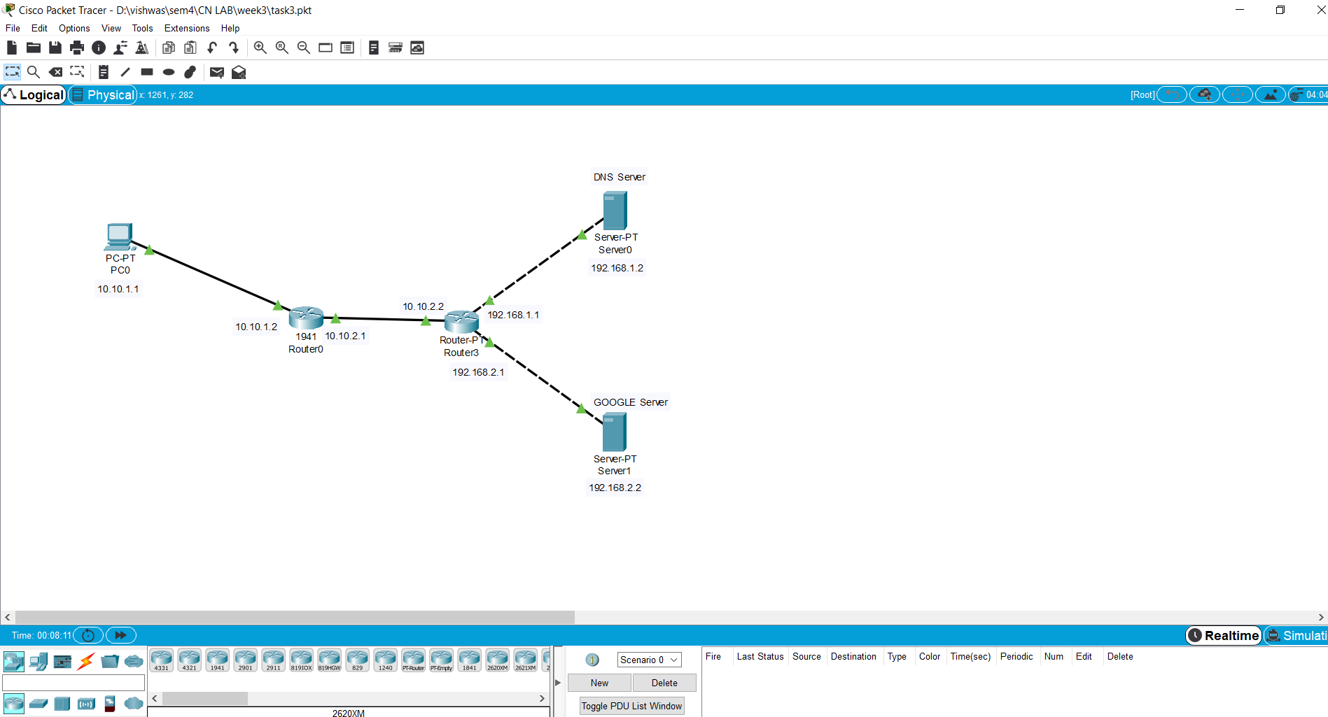

CONFIGURATIONS :

HOST A : IP Address ---> 10.10.1.1 Gateway > 10.10.1.2

DNS Server > 192.168.1.2

ROUTER 1 : Incoming Interface IP --> 10.10.1.2 (Fast ethernet 0) OUtgoing Interface IP --> 10.10.2.1 (Fast ethernet 1)

ROUTER 2 : Incoming Interface IP --> 10.10.2.2 (Fast ethernet 0) OUtgoing Interface1 IP --> 192.168.1.1 (Fast ethernet 1) Outgoing Interface2 IP --> 192.168.2.1 (External added interface)

DNS Server : IP Address > 192.168.1.2

Default Gateway : 192.168.1.1

WEB Server : IP Address > 192.168.2.2

Default Gateway : 192.168.2.1

# ROUTING TABLE ENTRIES :

|  |  |  |
| --- | --- | --- |
| Router name | Network | Gateway |
| ROUTER 1 | 192.168.1.0 | 10.10.2.2 |
| ROUTER 1 | 192.168.2.0 | 10.10.2.2 |
| ROUTER 2 | 10.10.1.0 | 10.10.2.1 |

**STEPS OF EXECUTION :**

1. Firstly the topolgy was constructed and configured using the above details.
2. While configuing the DNS server (with the above information), a type-A record was also

added :

Record-type : Type-A

Name : google.com (NAME OF THE DOMAIN)

Address : IP address of web-server i.e. 192.168.2.2 (DOMAIN'S IP Address)

1. While configuring the Web Server (with the above information), the HTML page in the HTTP config information

is checked and we can add information over there to see the output over there.

1. As the topology is created and all the devices are configured, we open the PC's Desktop on the cisco packet tracer

and type the name of the domain to be looked for as "google.com".

1. Now we open the packet tracer in th SIMULATION MODE and apply the filters on it fo capturing only the following

protocols :

* 1. Transmission Control Protocol
  2. Address Resolution Protocol
  3. Domain Name Service
  4. Hyper Text Transfer Protocol

1. Now, on a proper configuration based topology, we achieve the web request from the web-server.

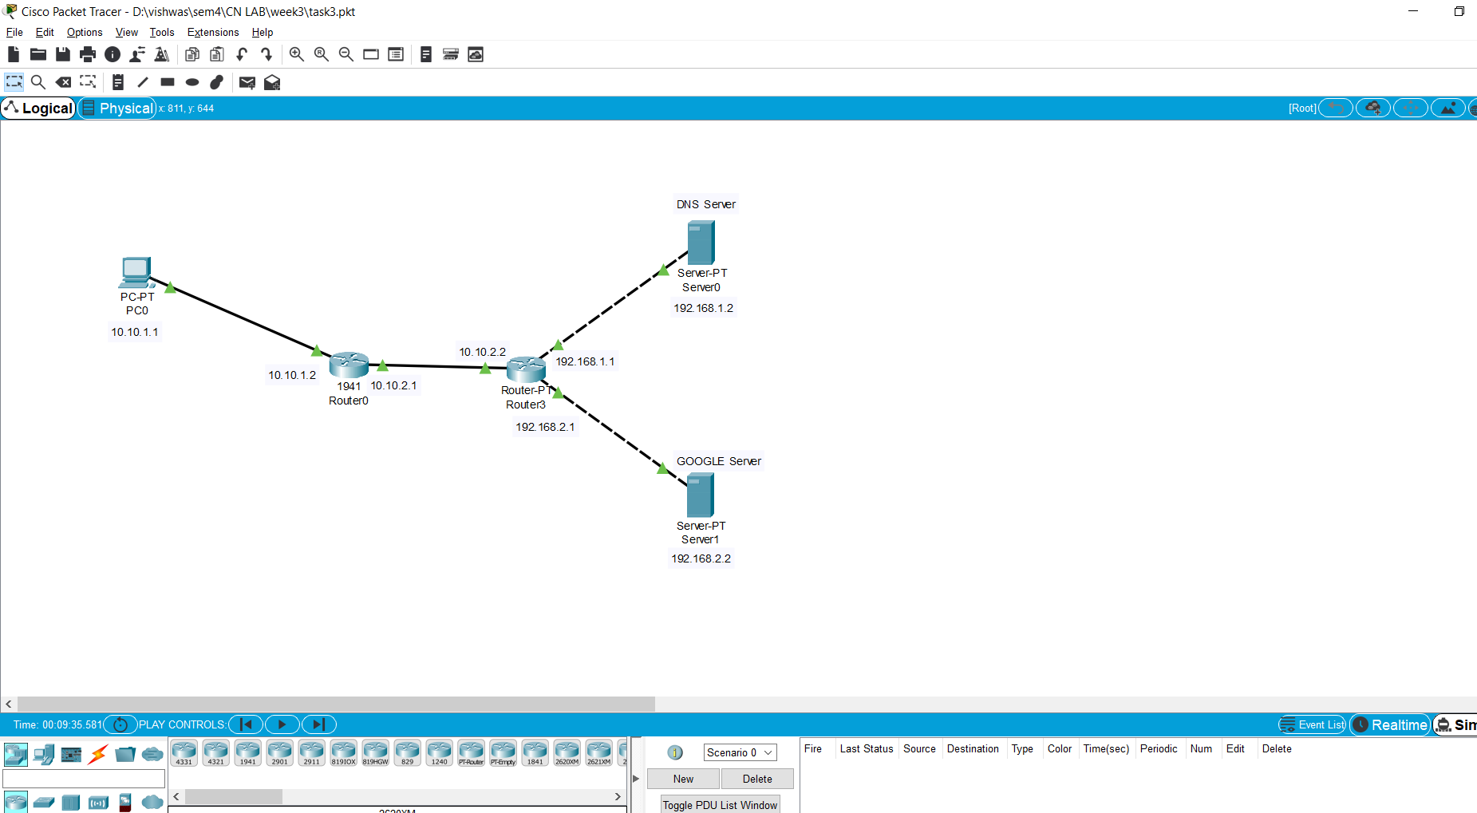

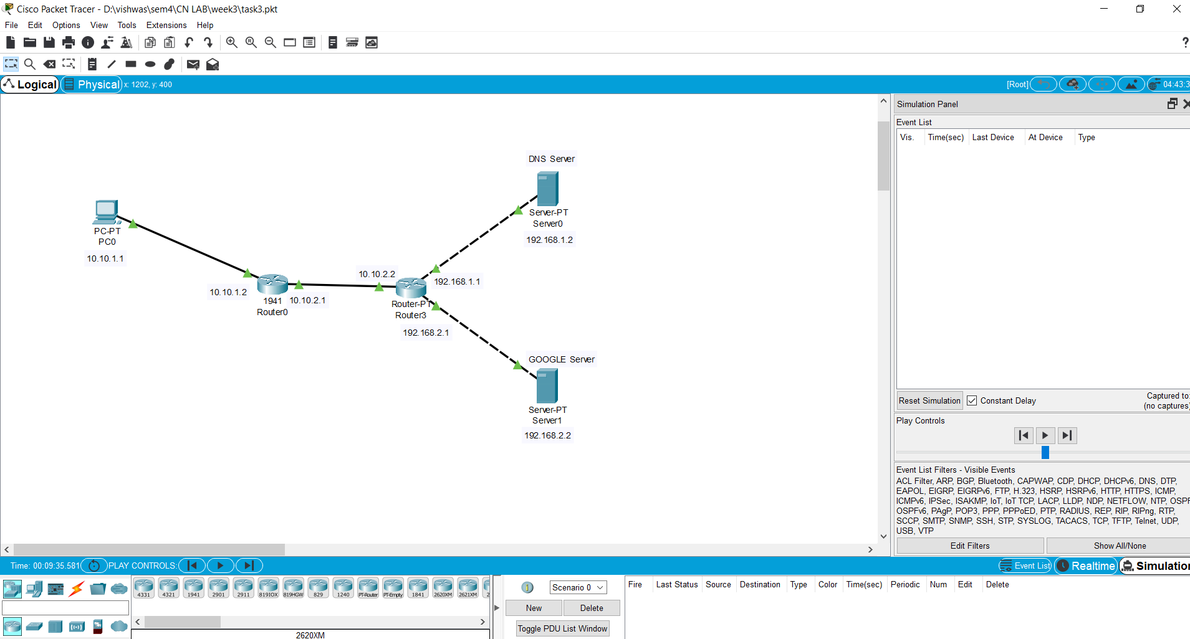

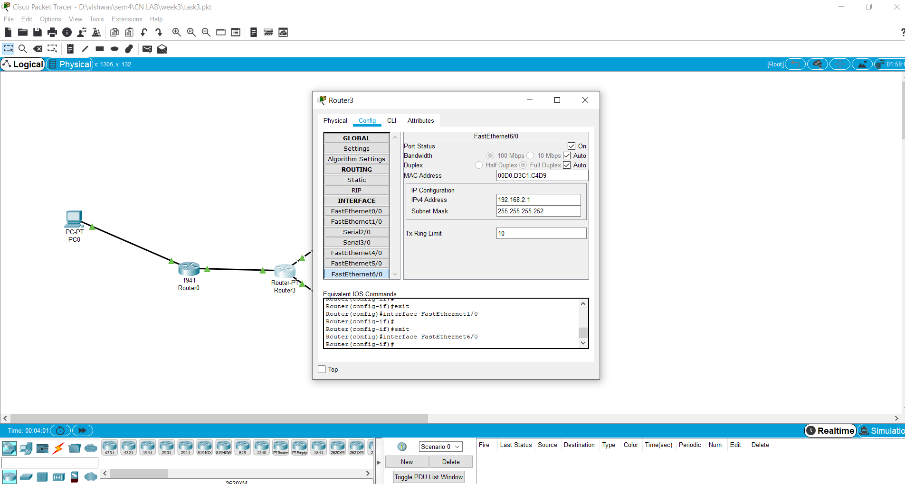

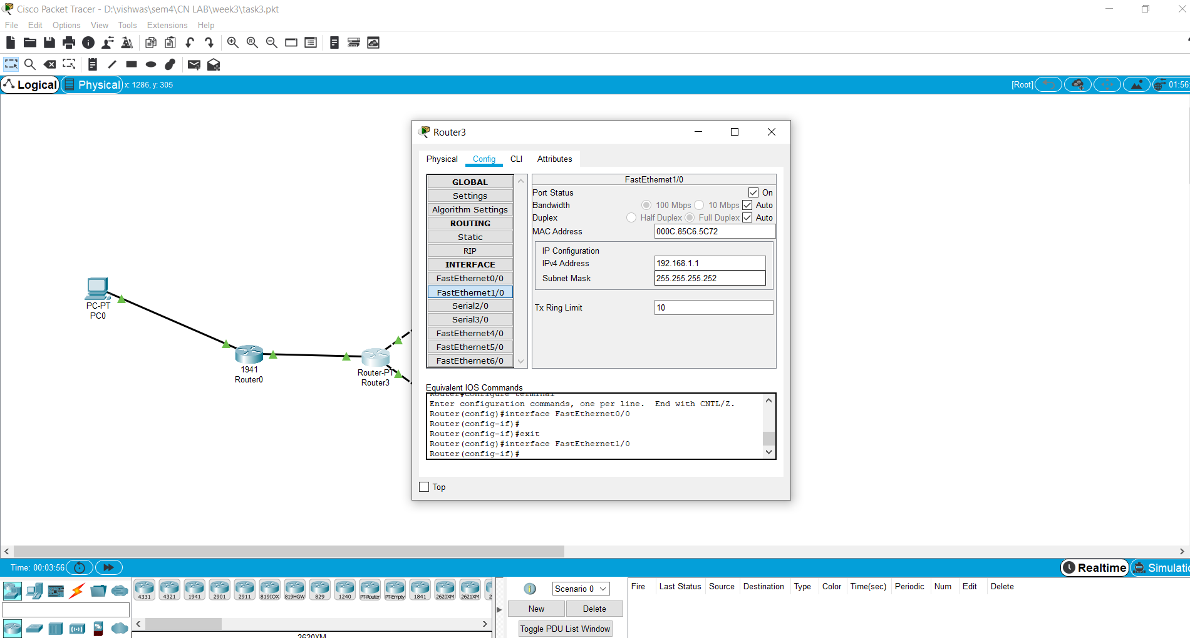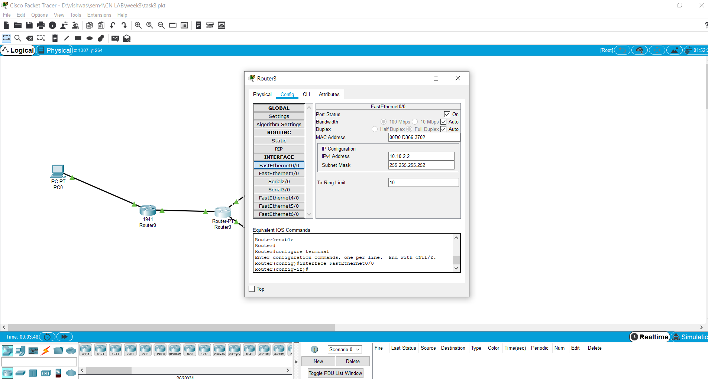

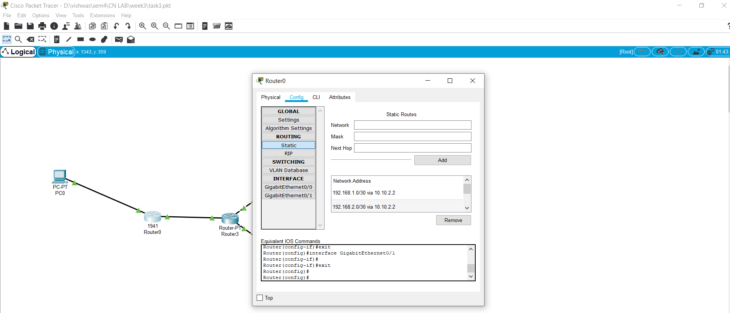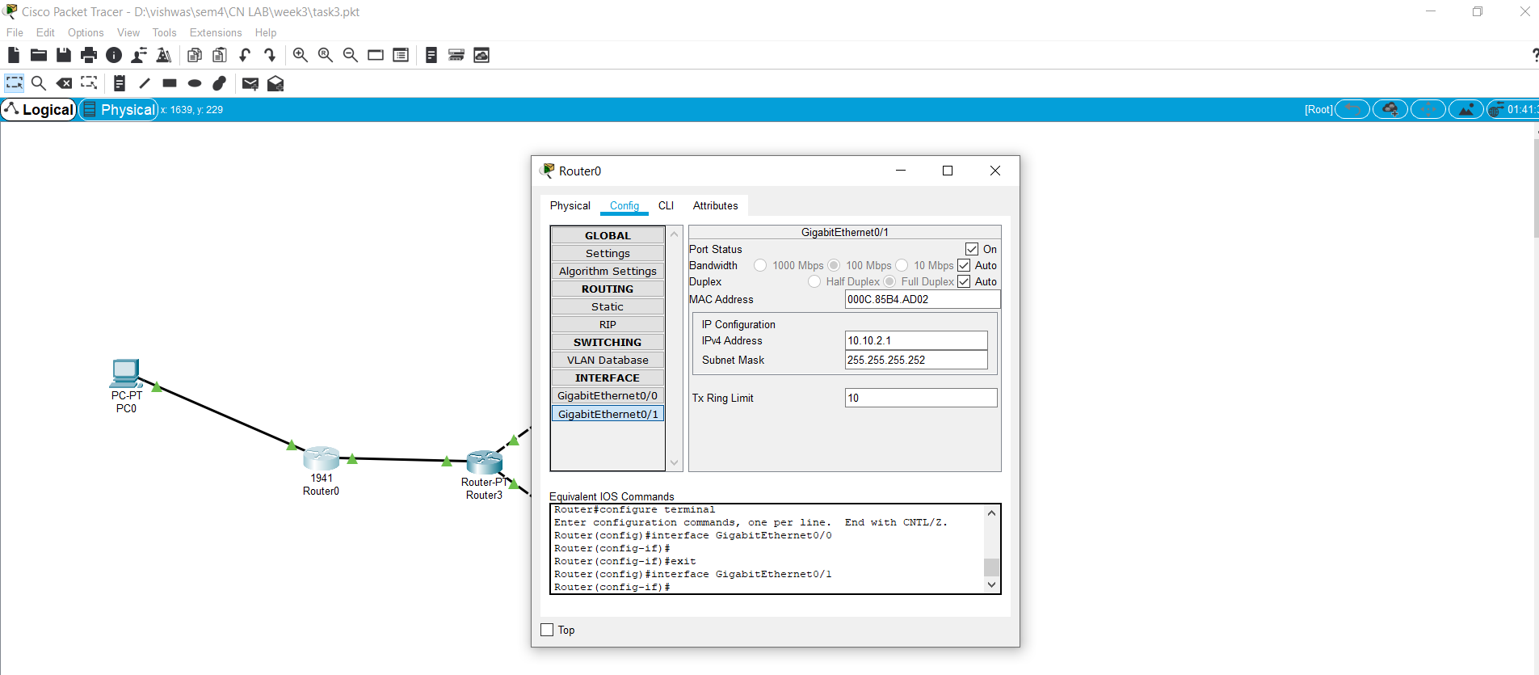

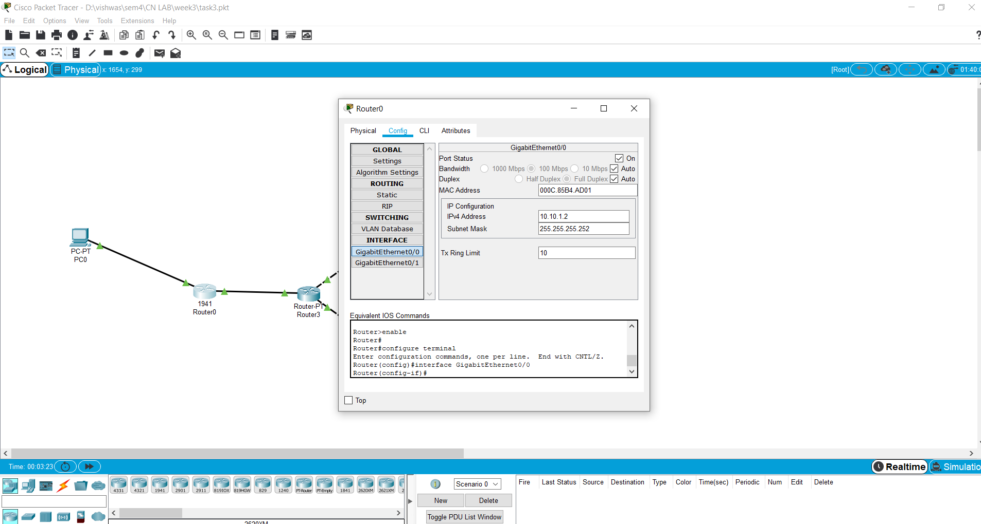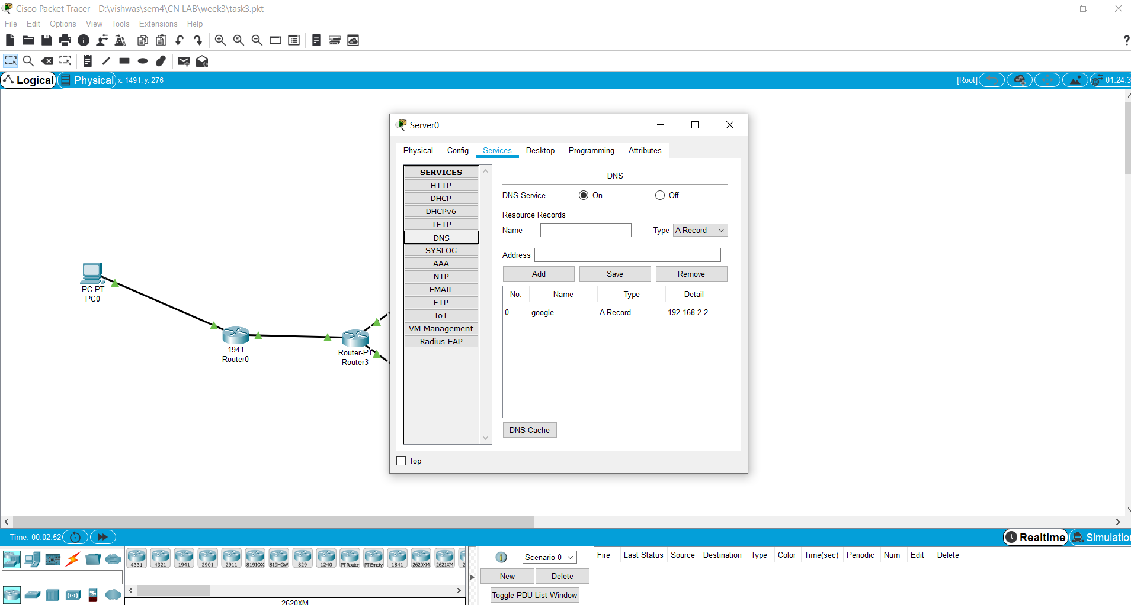

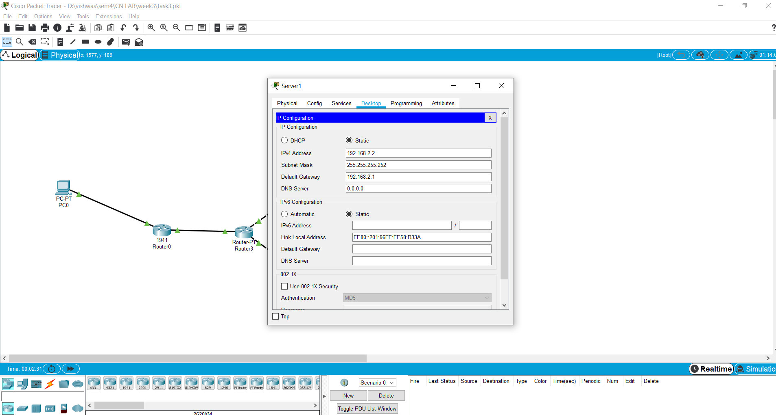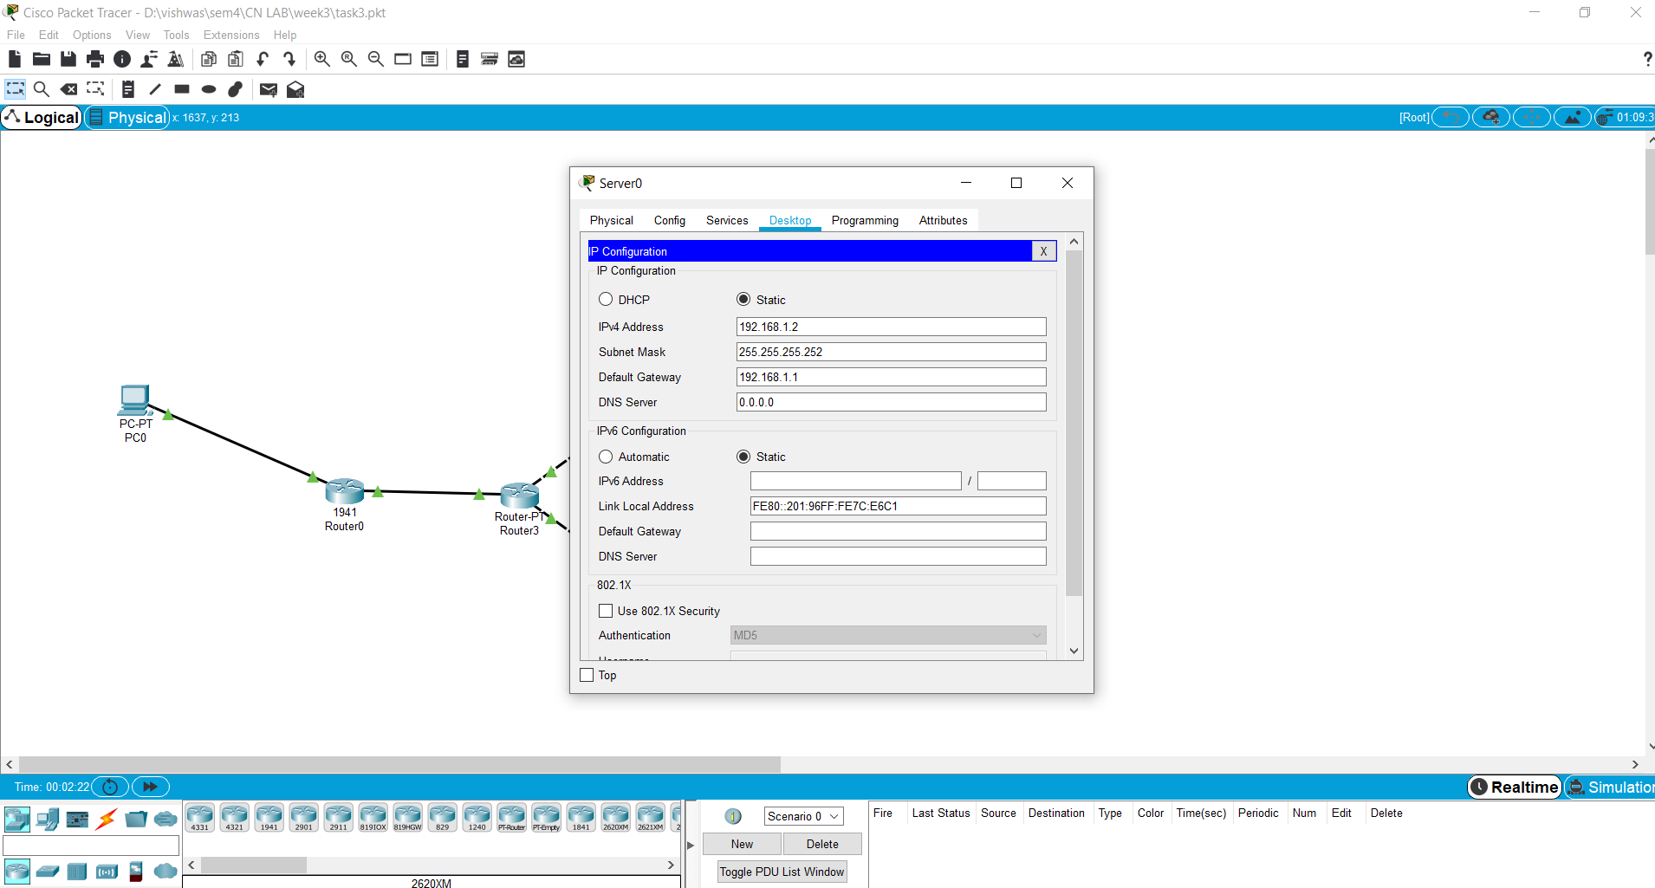

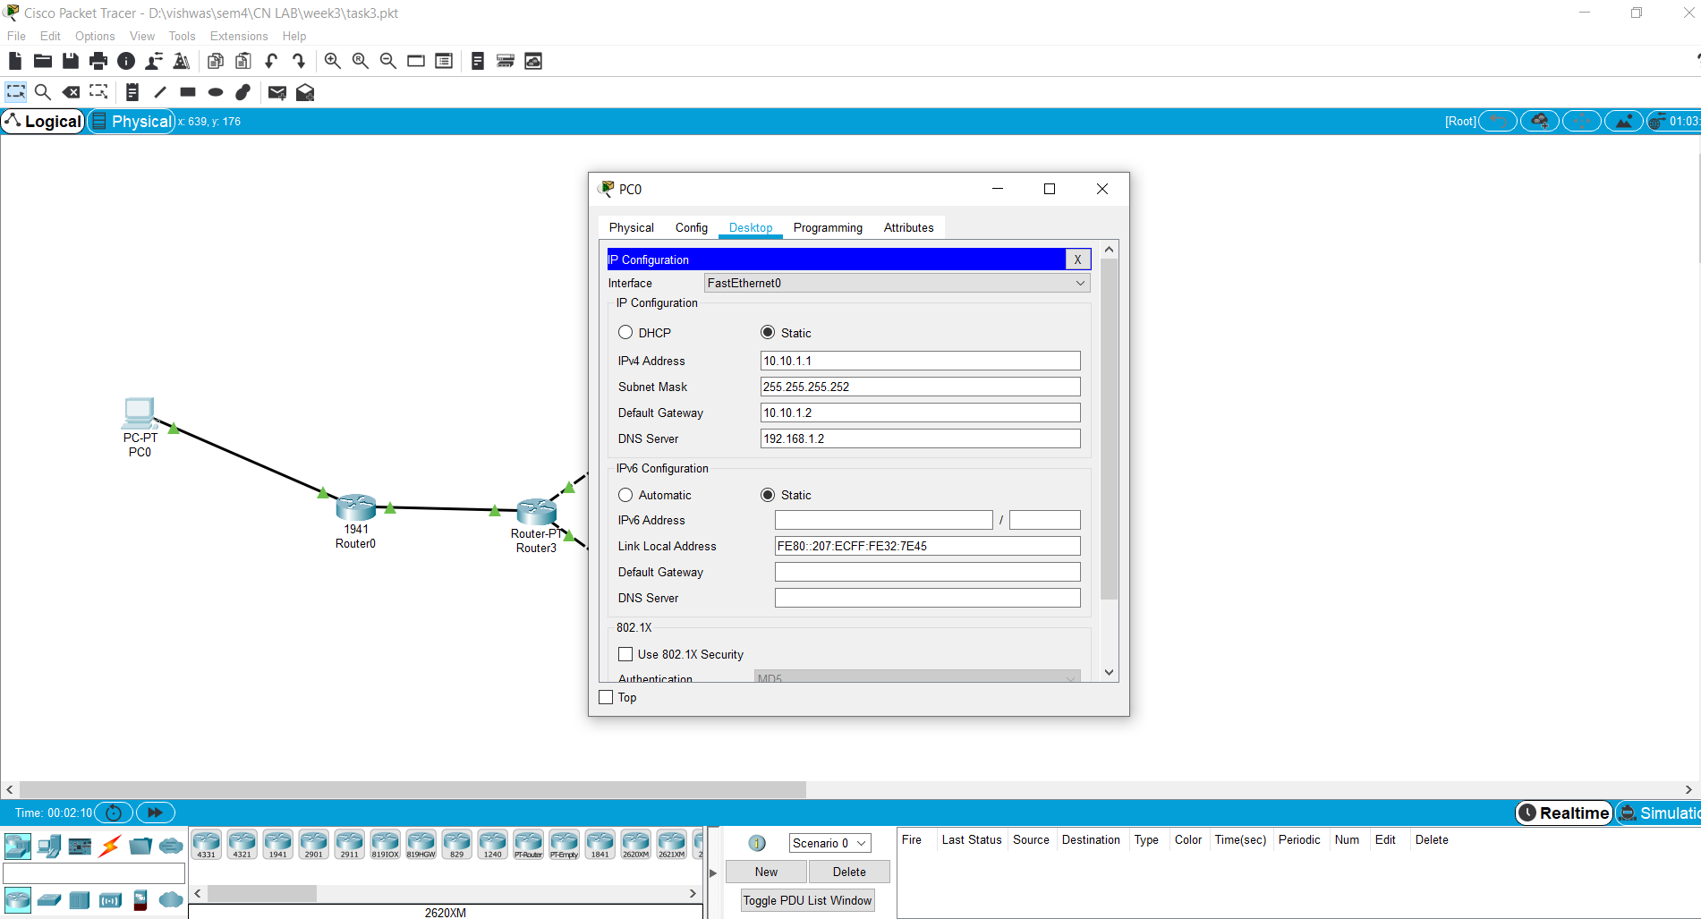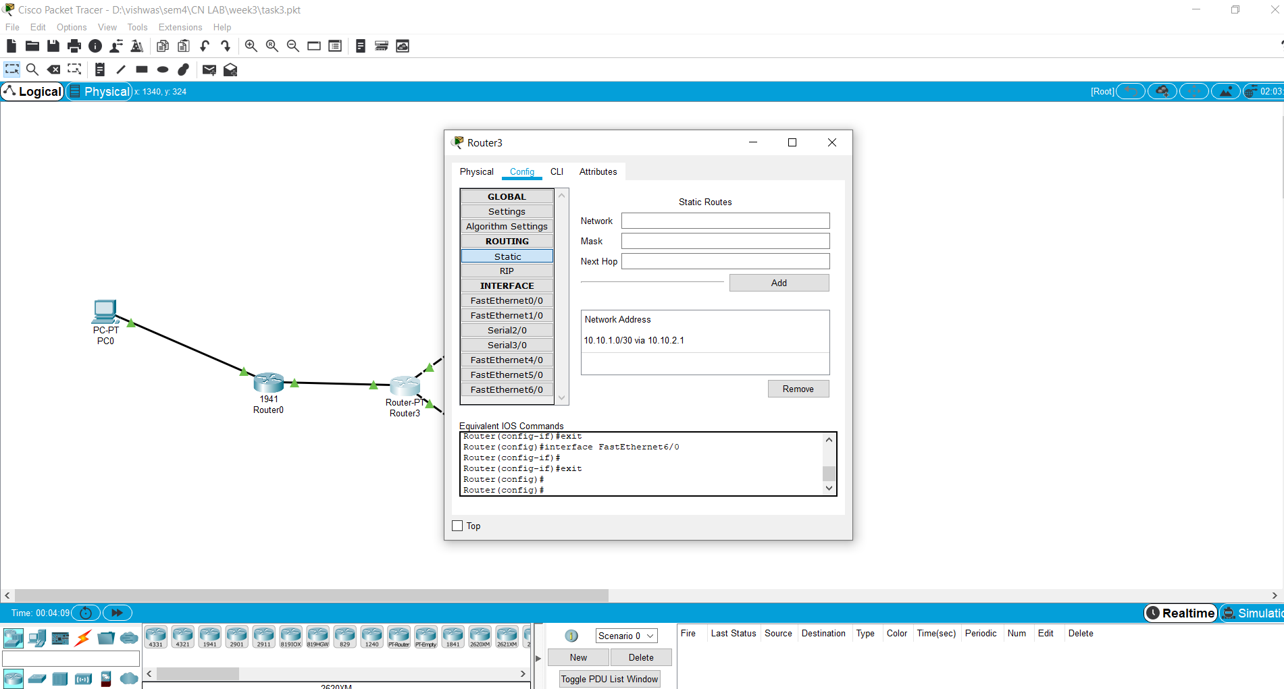

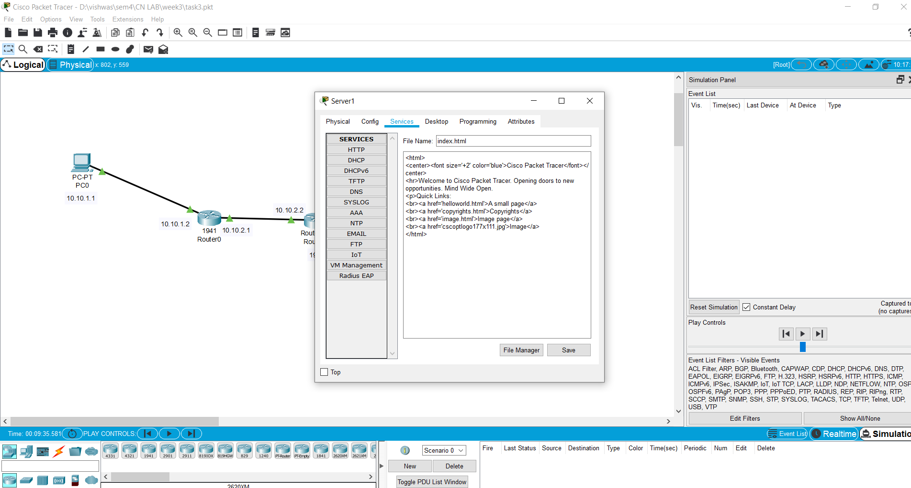

**OBSERVATIONS :**

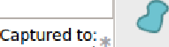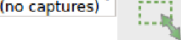

1. When the request for the domain "google.com" was made then because DNS serevr did not had the address in the cache the query took more

time to resolve the page (access the page back to the client from the web server) than in the followed request.

Time for 1st request : 0.328 seconds to capture (total time to fetch the page back.) Time for 2nd request : 0.019 seconds to capture (total time to fetch the page back.)

1. The reason for such a difference in time in the 2 requests being that DNS upon the first request of the web-server from the client

cached the DNS-name and the IP address in its local DNS cache and on the subsequent request again doesn't need to search for the

web-server again.

1. The ARP packets flowing were only seen in the first DNS request and not in the subsequent requset as because of the DNS cache.

ALl other packets i.e. TCP, HTTP and DNS were seen in both the web-server requests.

1. The colour coding was observed in the simulation mode : ARP : Green

HTTP : Purple DNS : Brown TCP : Green

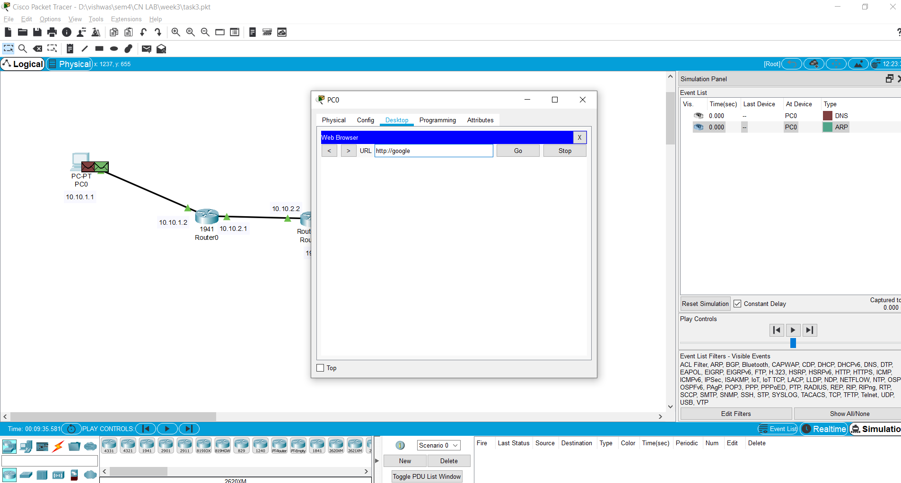

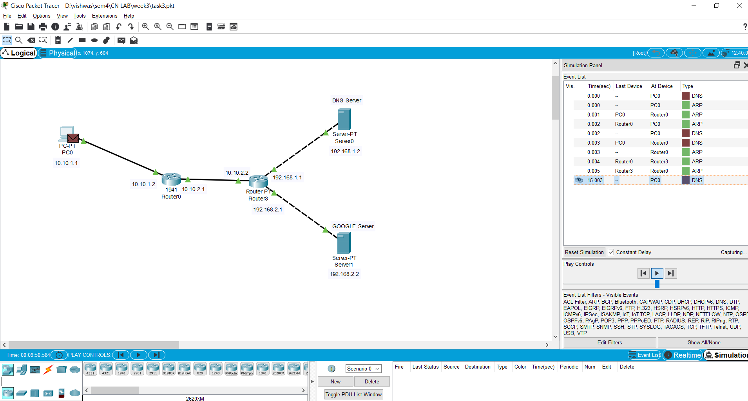

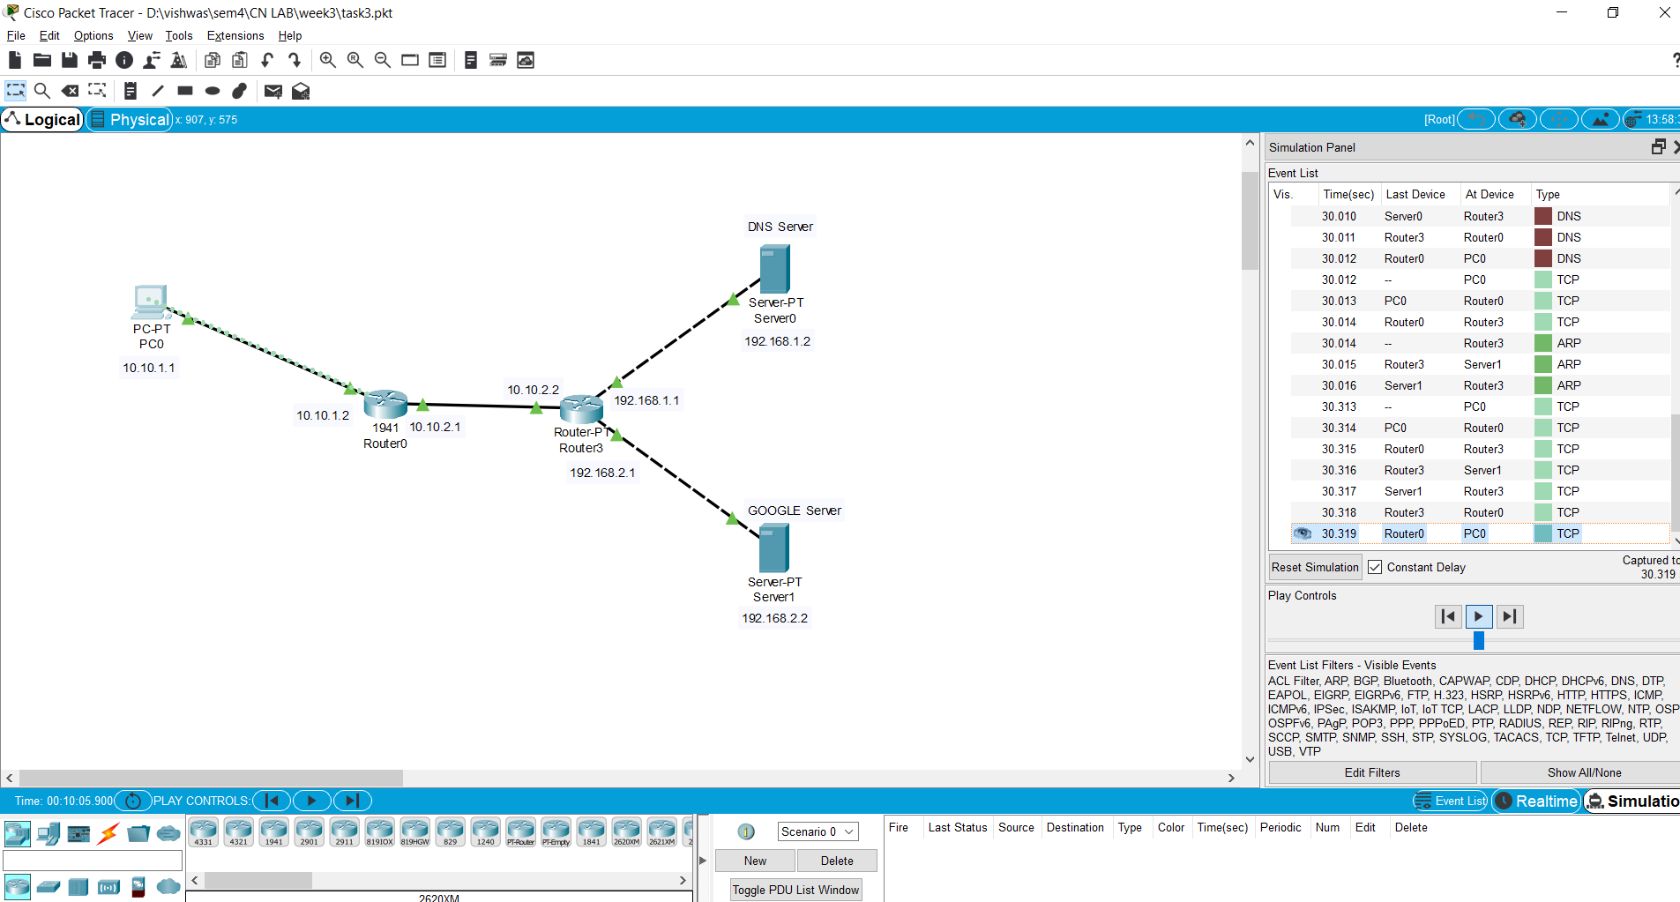

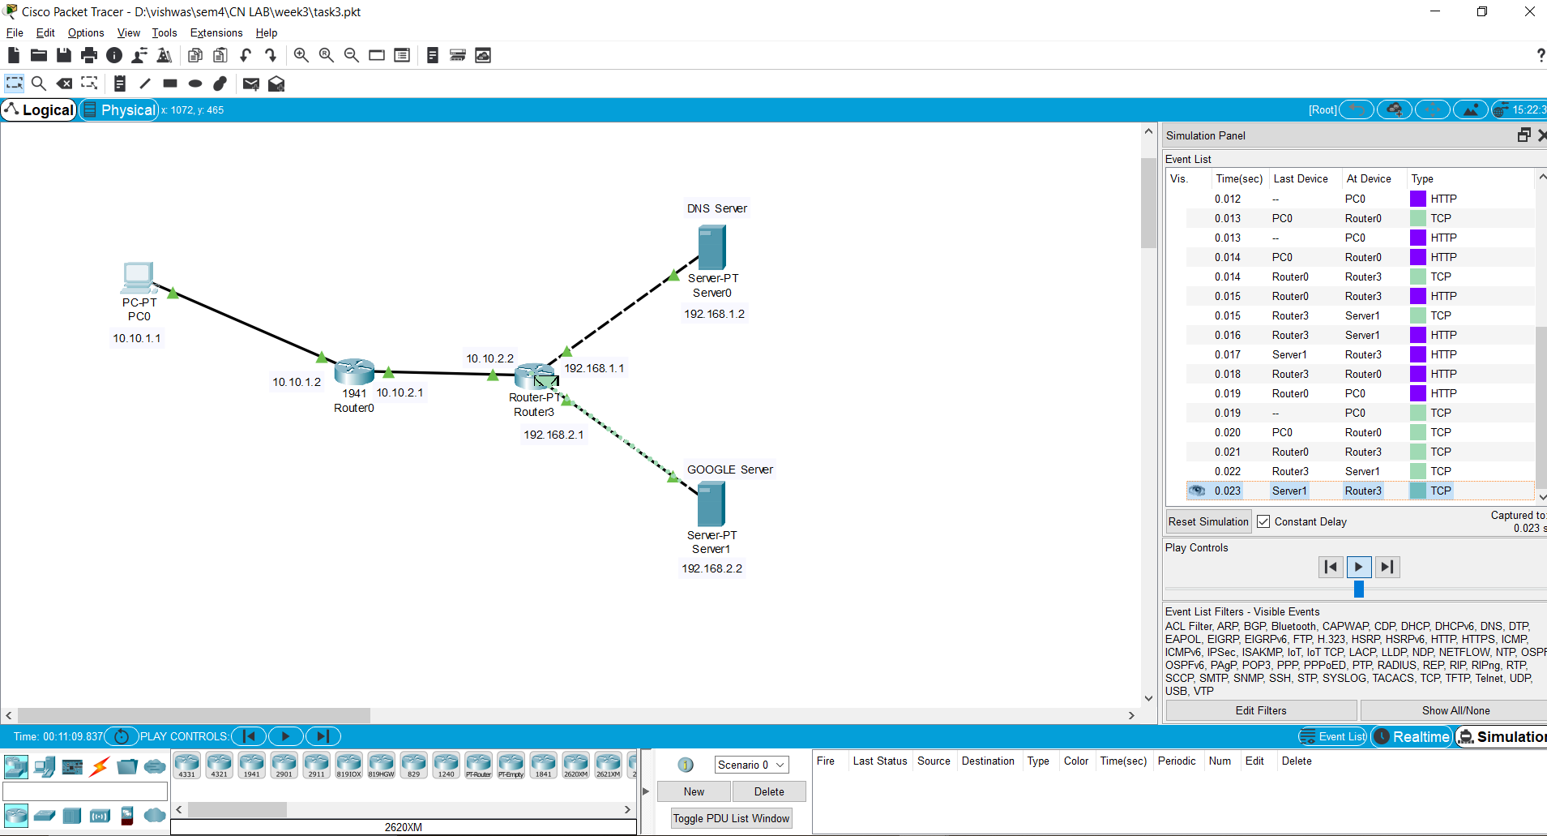

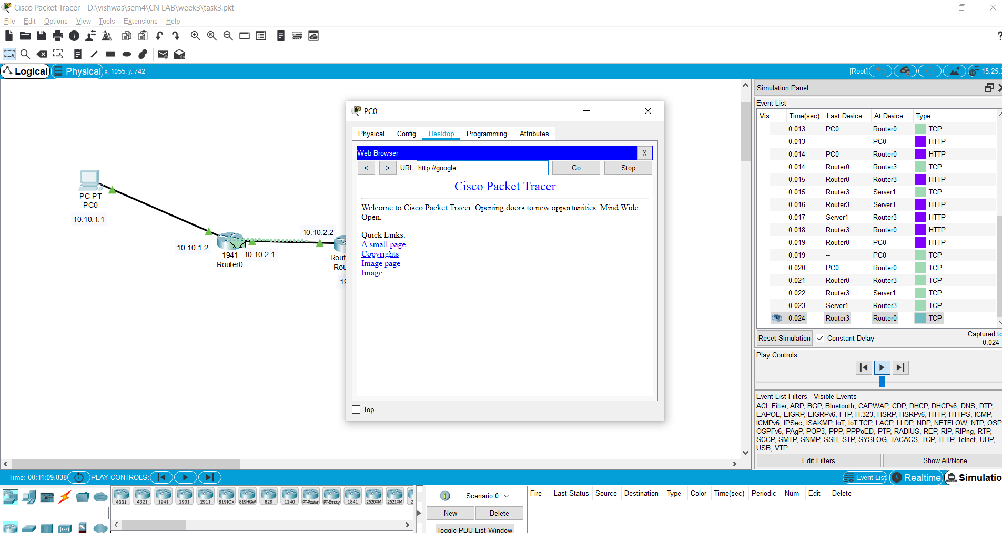

5.The event list occuring is shown in the screenshots attached at the different places in the topology. The number of packets got decreased by a fair amount as the ARP packets were not in the picture.

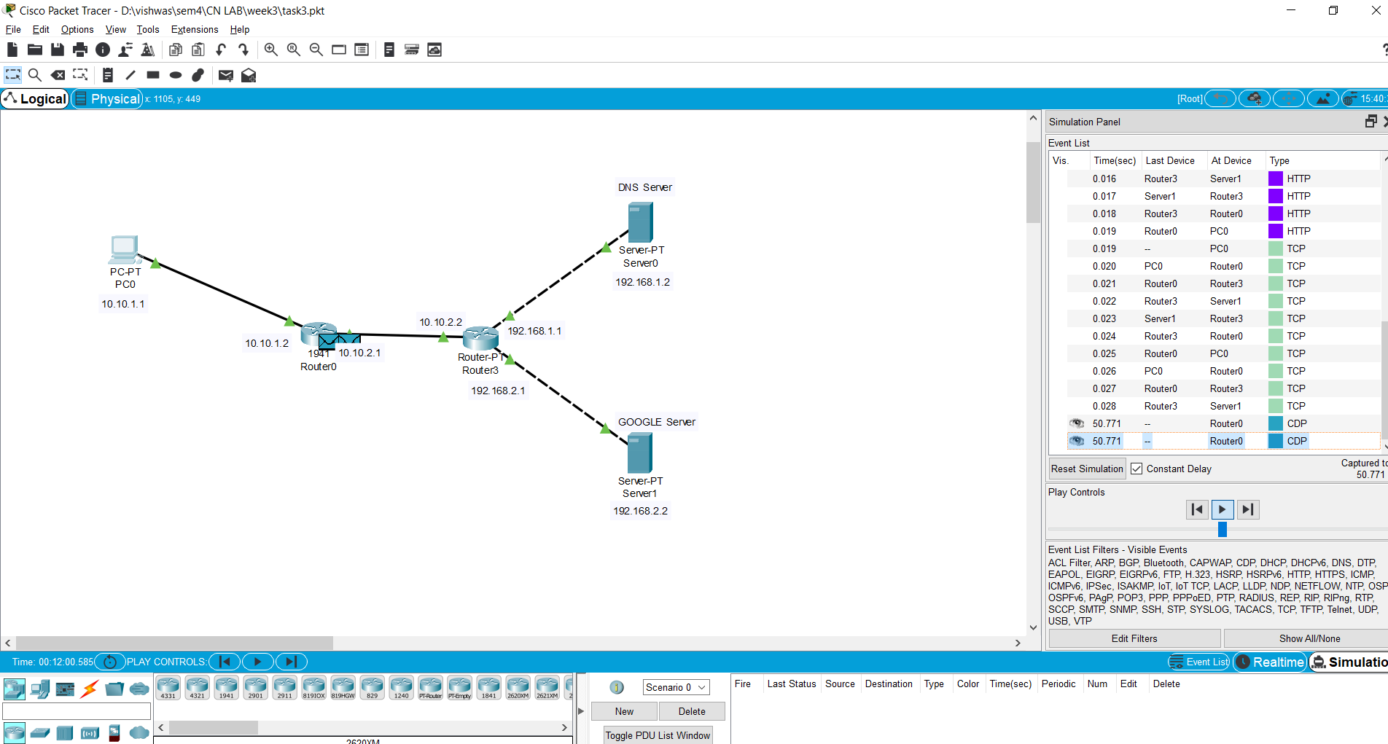

**EXCERCISE 2 : Connect DNS Server and Web Sever for the below toplogy and transmit the packets**

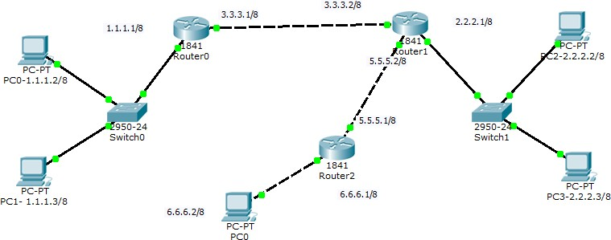

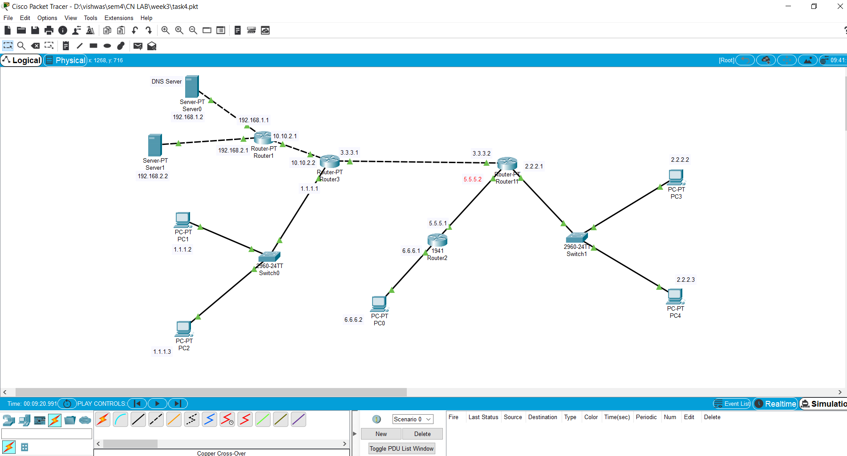

**Configurations:**

**PC0**: IP Address ---> 6.6.6.2

Gateway ---> 6.6.6.1

DNS : 192.168.2.2

**PC1**: IP Address ---> 1.1.1.2

Gateway ---> 1.1.1.1

DNS : 192.168.2.2

**PC2**: IP Address ---> 1.1.1.2

Gateway ---> 1.1.1.1

DNS : 192.168.2.2

**PC3**: IP Address ---> 2.2.2.2

Gateway ---> 2.2.2.1

DNS : 192.168.2.2

**PC4**: IP Address ---> 2.2.2.3

Gateway ---> 2.2.2.1

DNS : 192.168.2.2

**ROUTER3**: GigabitEthernet0/0 ---> 1.1.1.1

GigabitEthernet0/1 ---> 3.3.3.1

FastEthernet6/1 ---> 10.10.2.2

**ROUTER11**: FastEthernet0/0 ---> 3.3.3.2

FastEthernet0/1 ---> 5.5.5.2

FastEthernet6/1 ---> 2.2.2.1

**ROUTER2**: GigabitEthernet0/0 ---> 5.5.5.1

GigabitEthernet0/1 ---> 6.6.6.1

**ROUTER 1** : FastEthernet6/1 --> 10.10.2.1

FastEthernet0/0 --> 192.168.1.1

FastEthernet0/1 --> 192.168.2.1

**DNS Server** : IP Address--> 192.168.1.2

Default Gateway : 192.168.1.1

**WEB Server** : IP Address--> 192.168.2.2

Default Gateway : 192.168.2.1

|  |  |  |
| --- | --- | --- |
| **Router** | **Network** | **Next Hop** |
| Router 3 | a)2.2.2.0  b)6.6.6.0  c) 192.168.1.0  d) 192.168.2.0 | a)3.3.3.2  b)3.3.3.2  c) 10.10.2.1  d) 10.10.2.1 |
| Router 11 | a)6.6.6.0  b)1.1.1.0  c) 192.168.1.0  d) 192.168.2.0 | a)5.5.5.1  b)3.3.3.1  c) 10.10.2.1  d) 10.10.2.1 |
| Router 2 | a)1.1.1.0  b)2.2.2.0  c) 192.168.1.0  d) 192.168.2.0 | a)5.5.5.2  b)5.5.5.2  c) 10.10.2.1  d) 10.10.2.1 |
| Router 1 | a)1.1.1.0  a)2.2.2.0  b)6.6.6.0 | c) 10.10.2.2  c) 10.10.2.2  c) 10.10.2.2 |

**STEPS OF EXECUTION :**

1)Firstly the topolgy was constructed and configured using the above details.

2)While configuing the DNS server (with the above information), a type-A record was also

added:

Record-type : Type-A

Name : google.com (NAME OF THE DOMAIN)

Address: IP address of web-server i.e. 192.168.2.2 (DOMAIN'S IP Address)

3) While configuring the Web Server (with the above information), the HTML page in the HTTP config information is checked and we can add information over there to see the output over there.

4) As the topology is created and all the devices are configured, we open the PC's Desktop on the cisco packet tracer and type the name of the domain to be looked for as "google.com".

5) Now we open the packet tracer in th SIMULATION MODE and apply the filters on it fo capturing only the following

protocols :

* 1. Transmission Control Protocol
  2. Address Resolution Protocol
  3. Domain Name Service
  4. Hyper Text Transfer Protocol

6) Now, on a proper configuration based topology, we achieve the web request from the web-server.

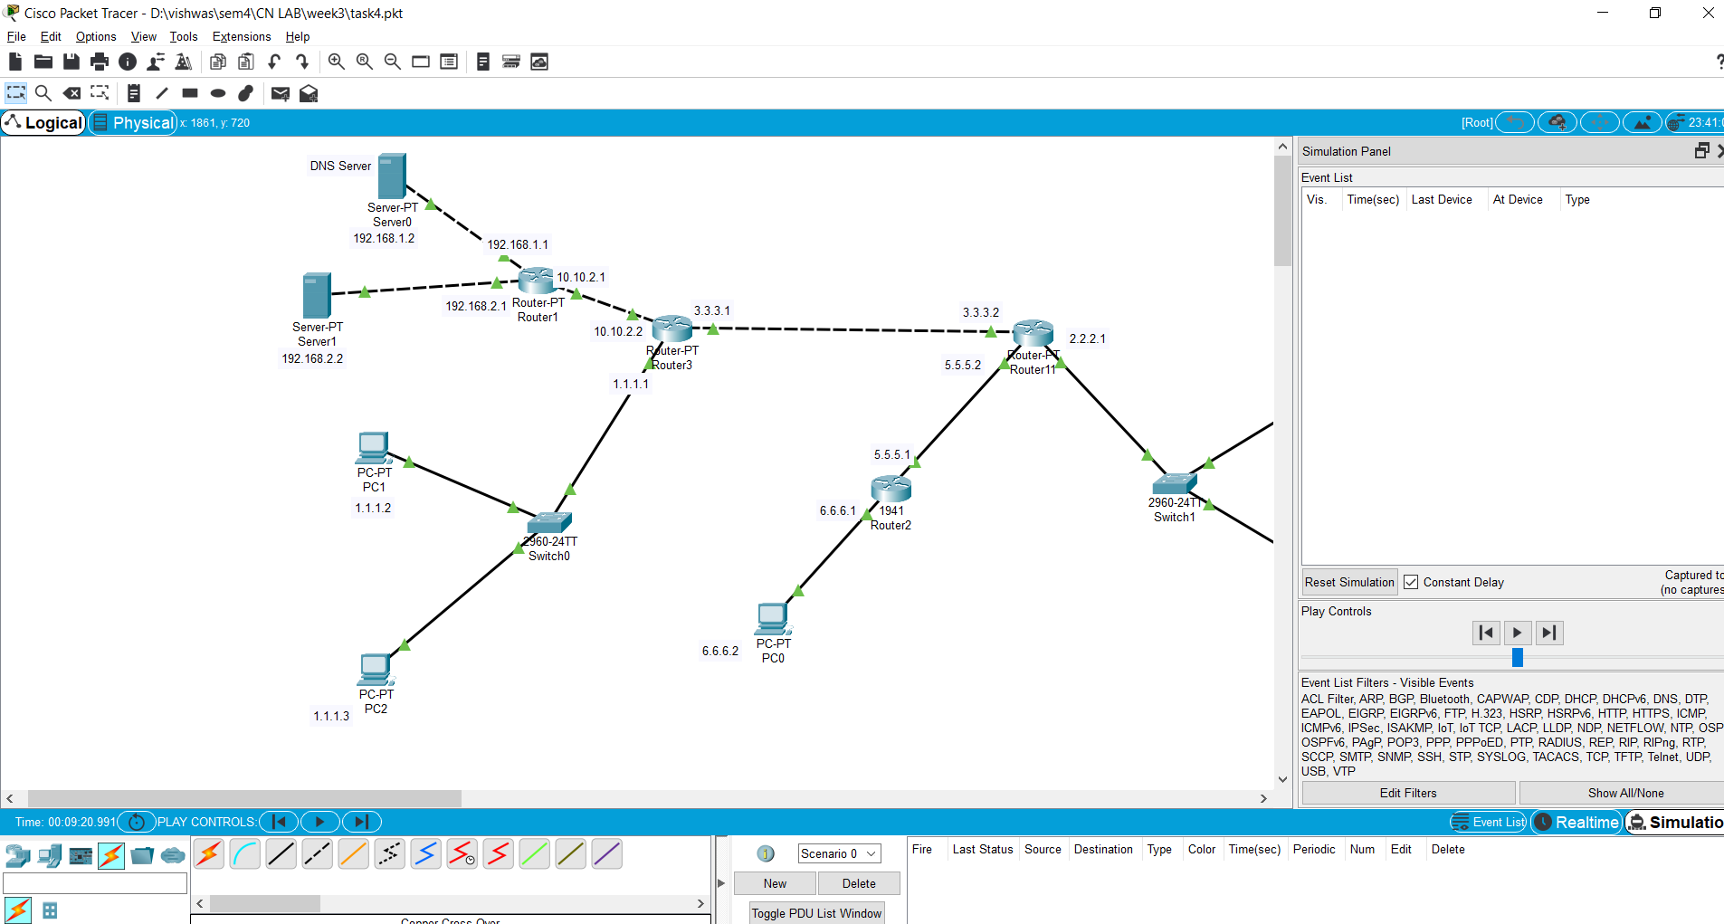

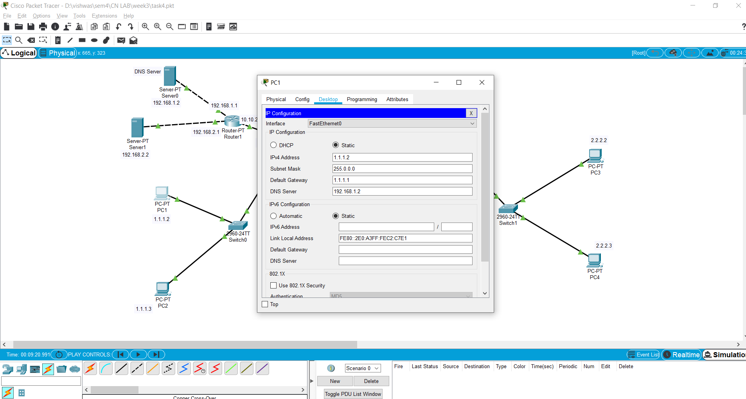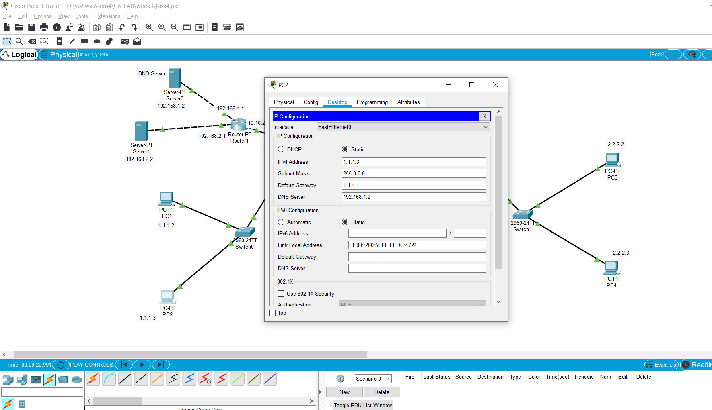

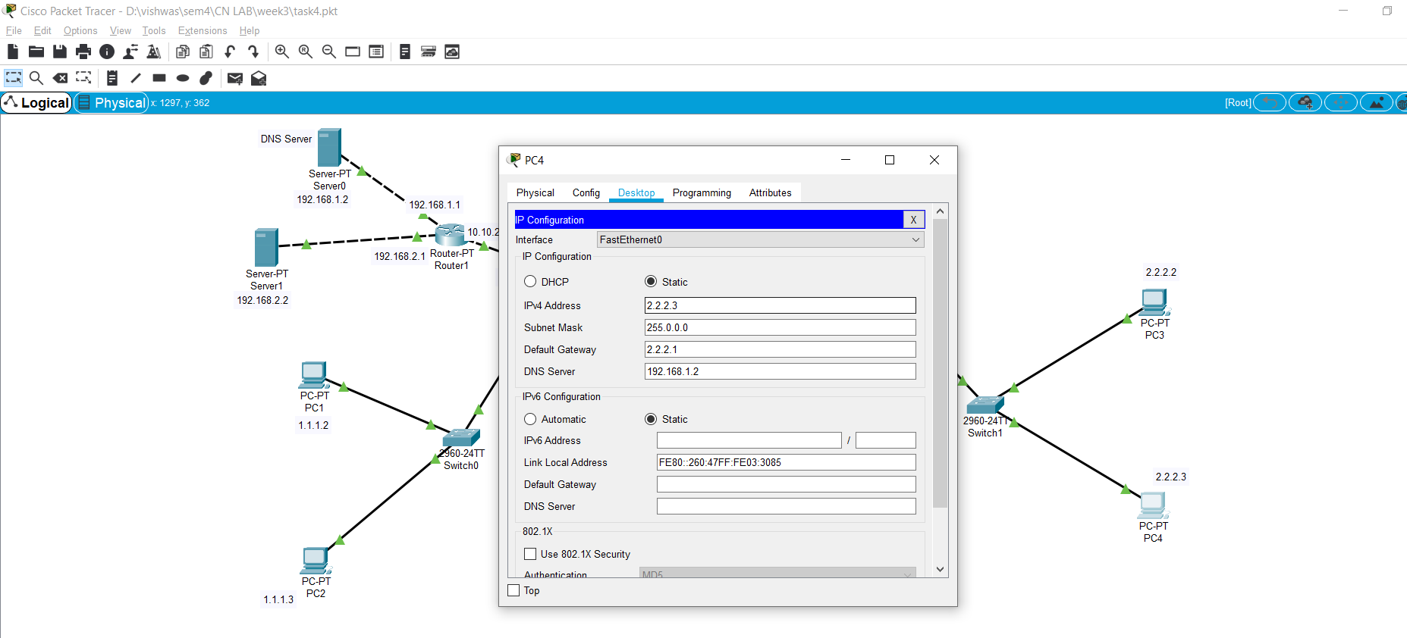

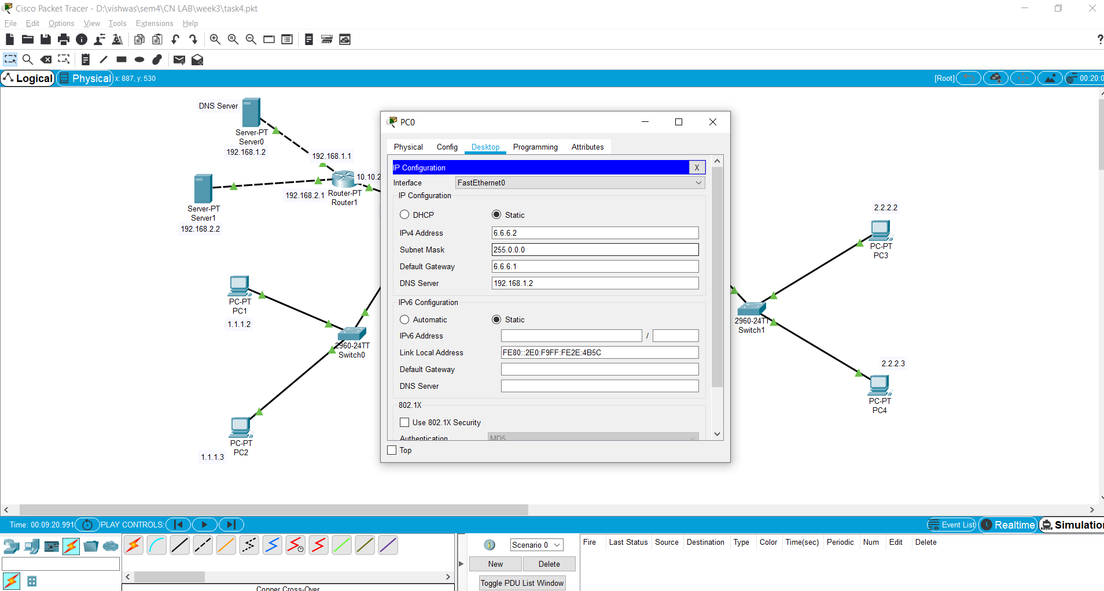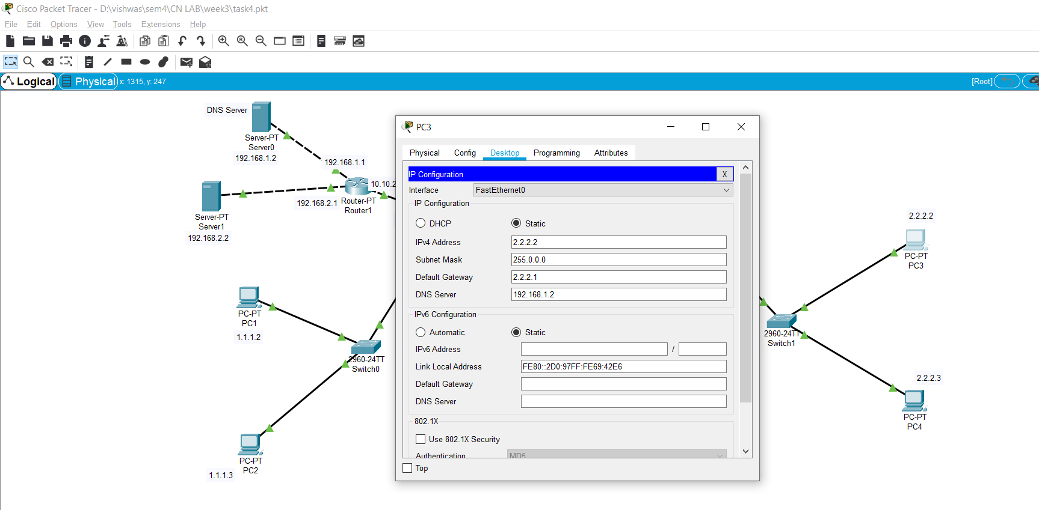

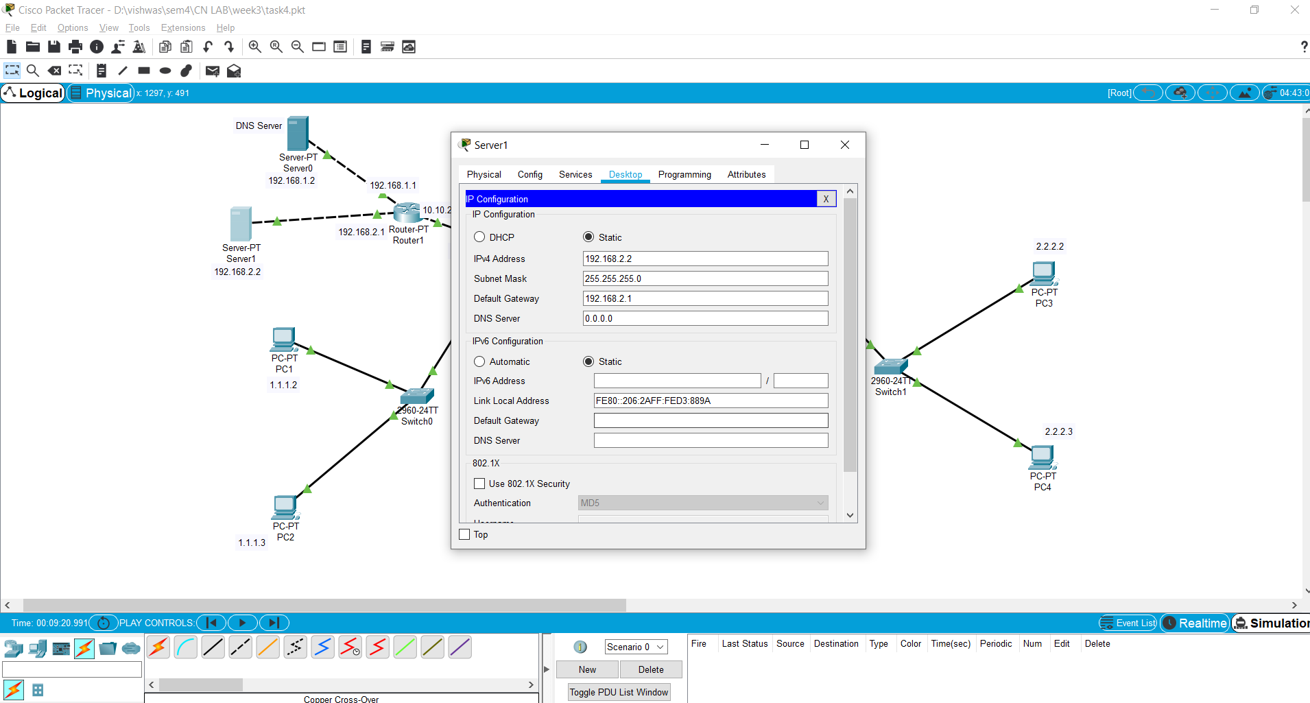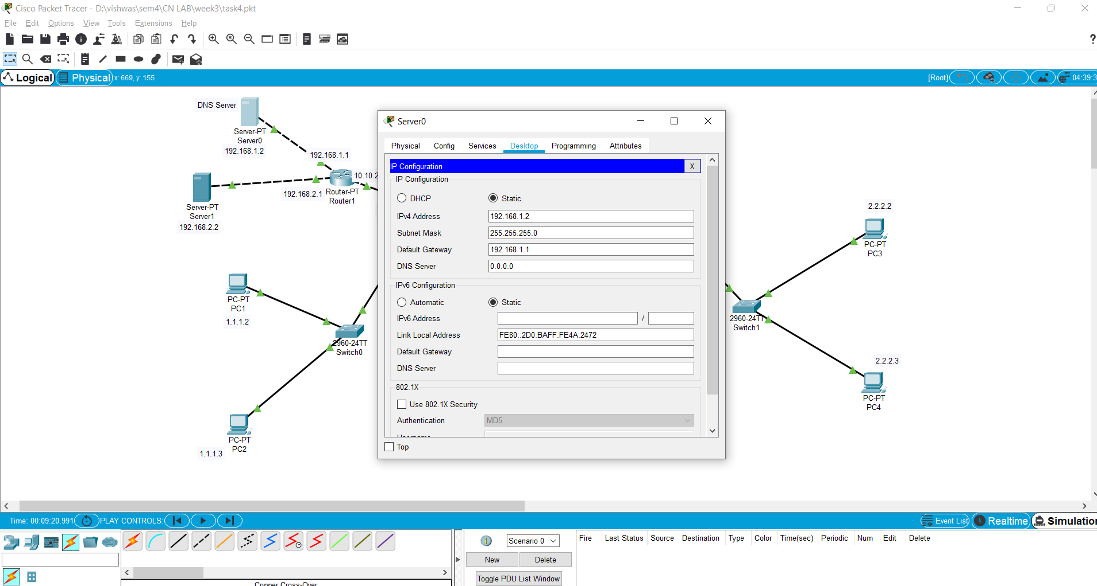

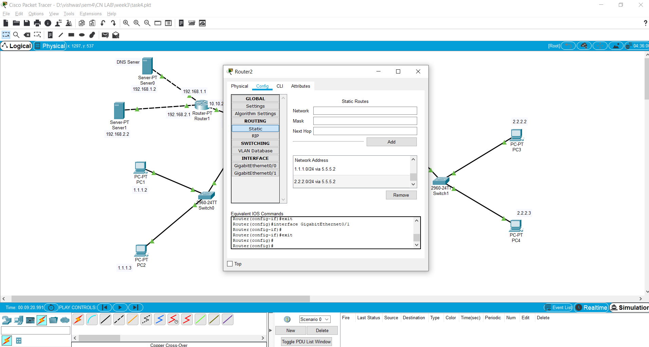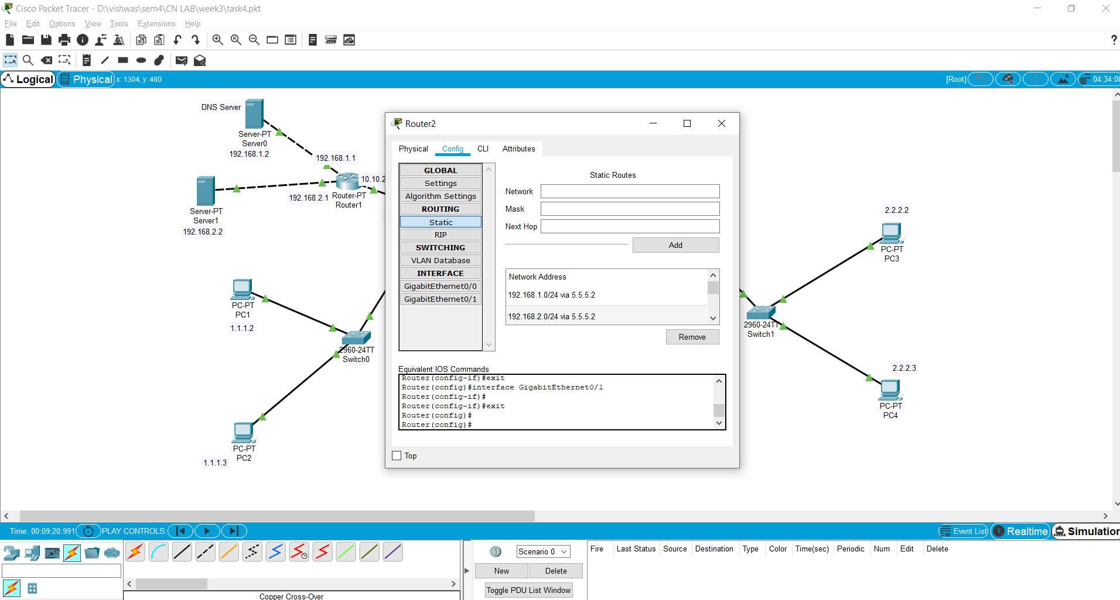

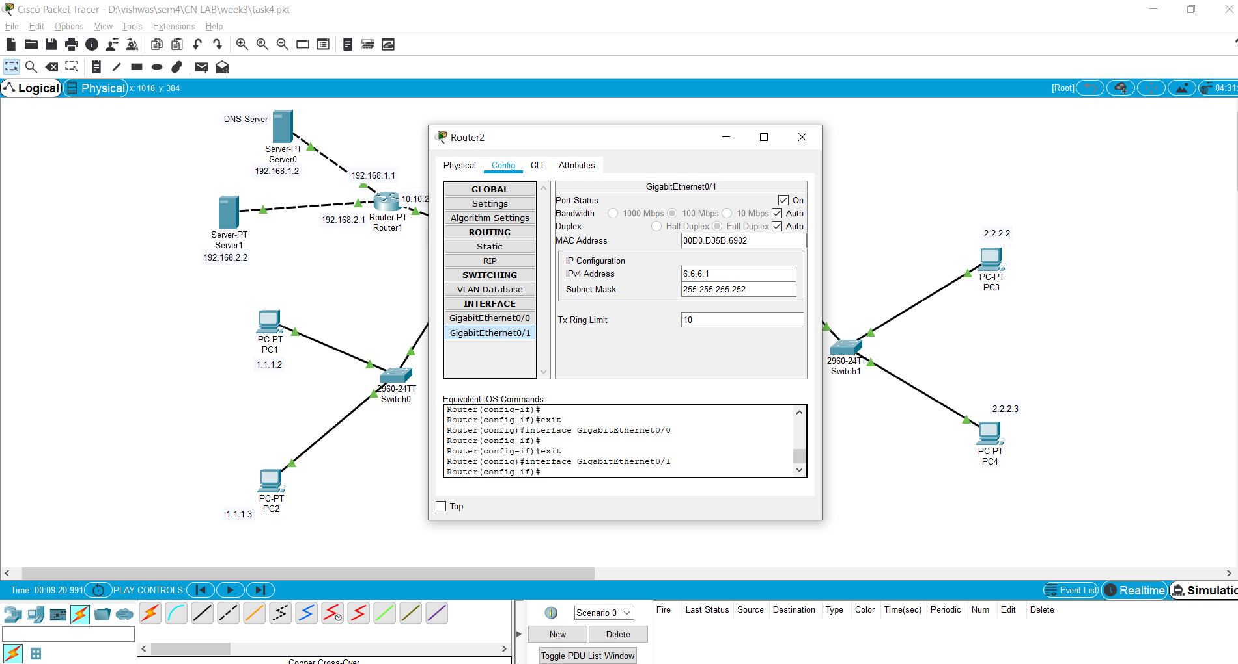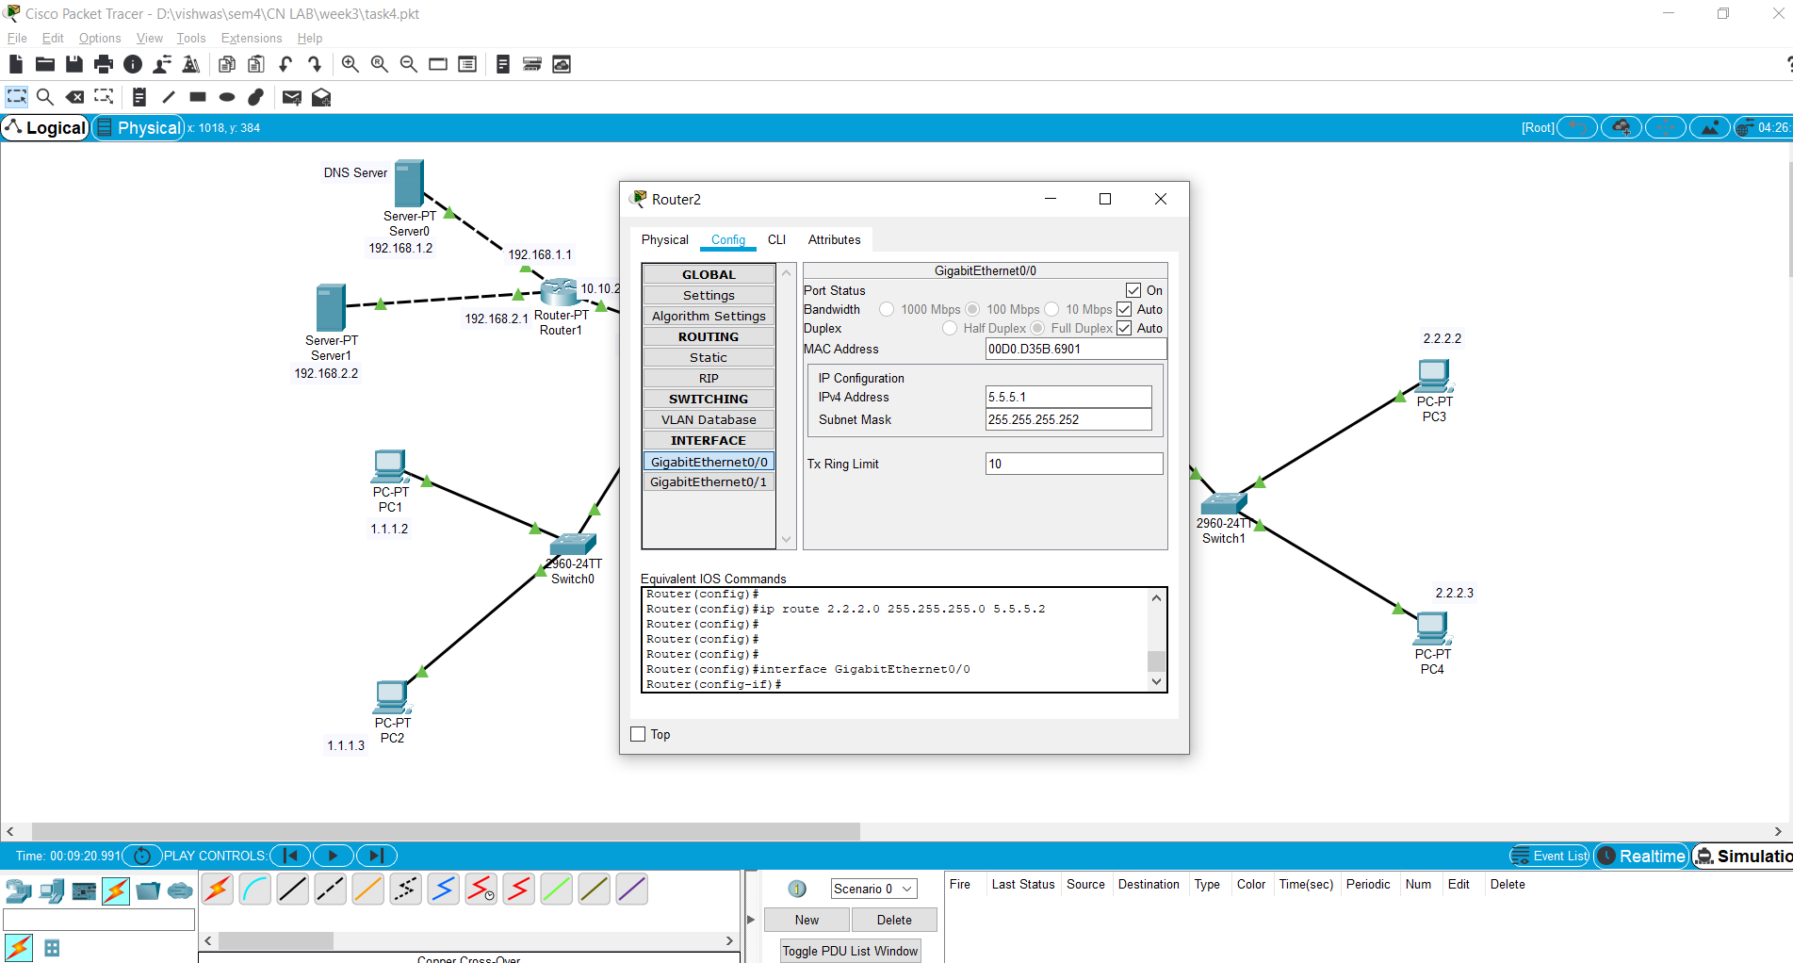

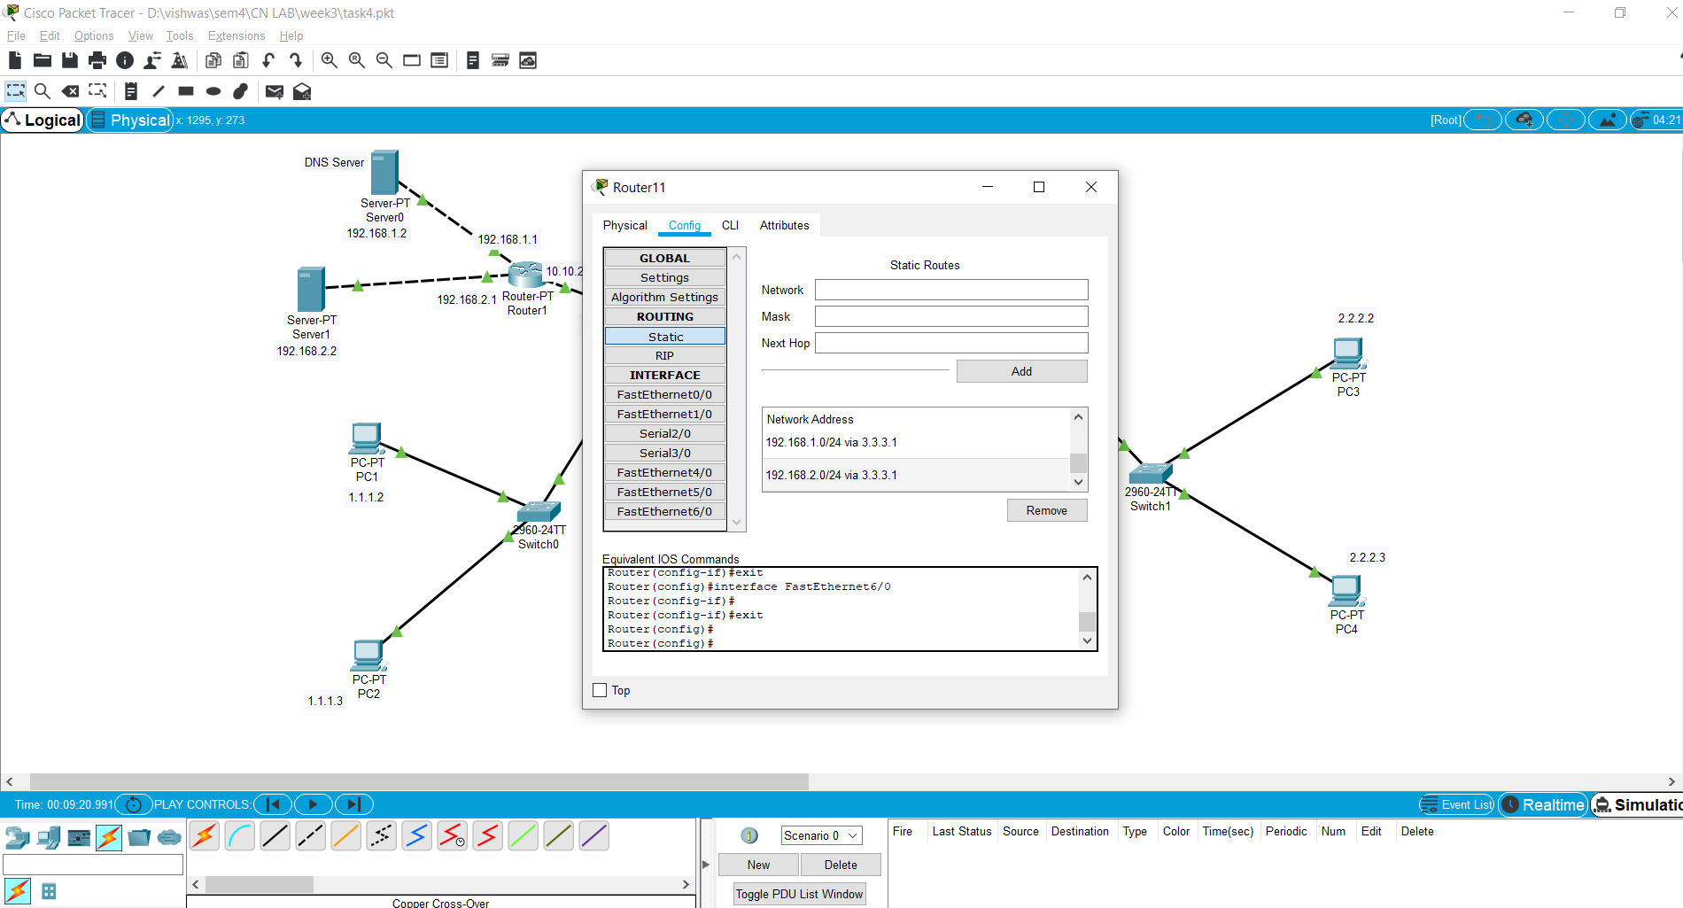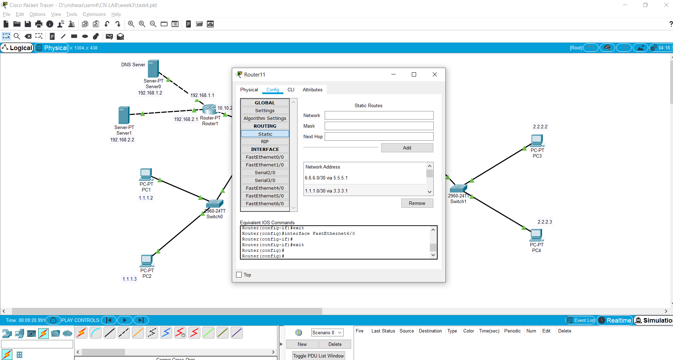

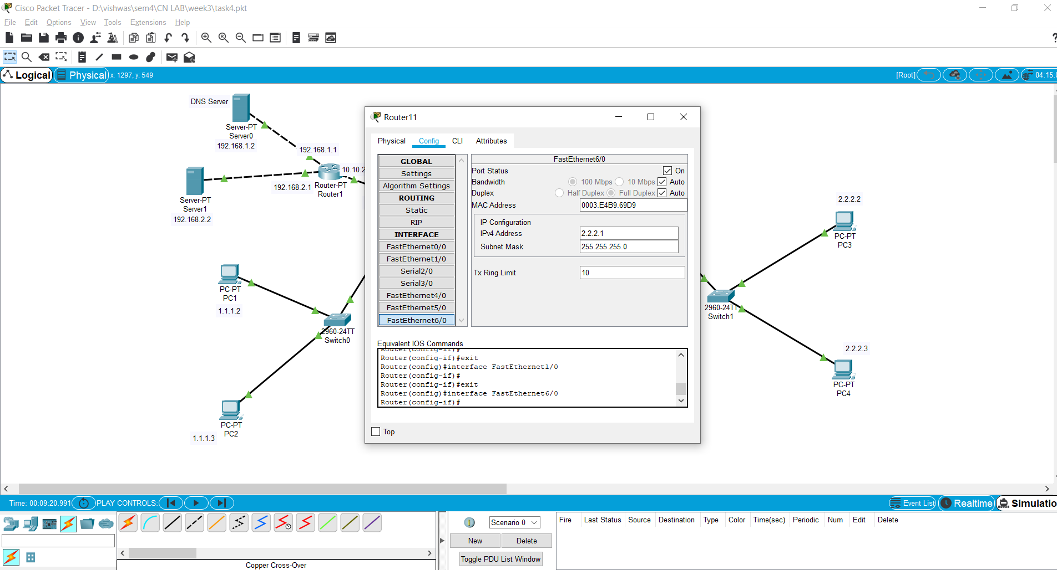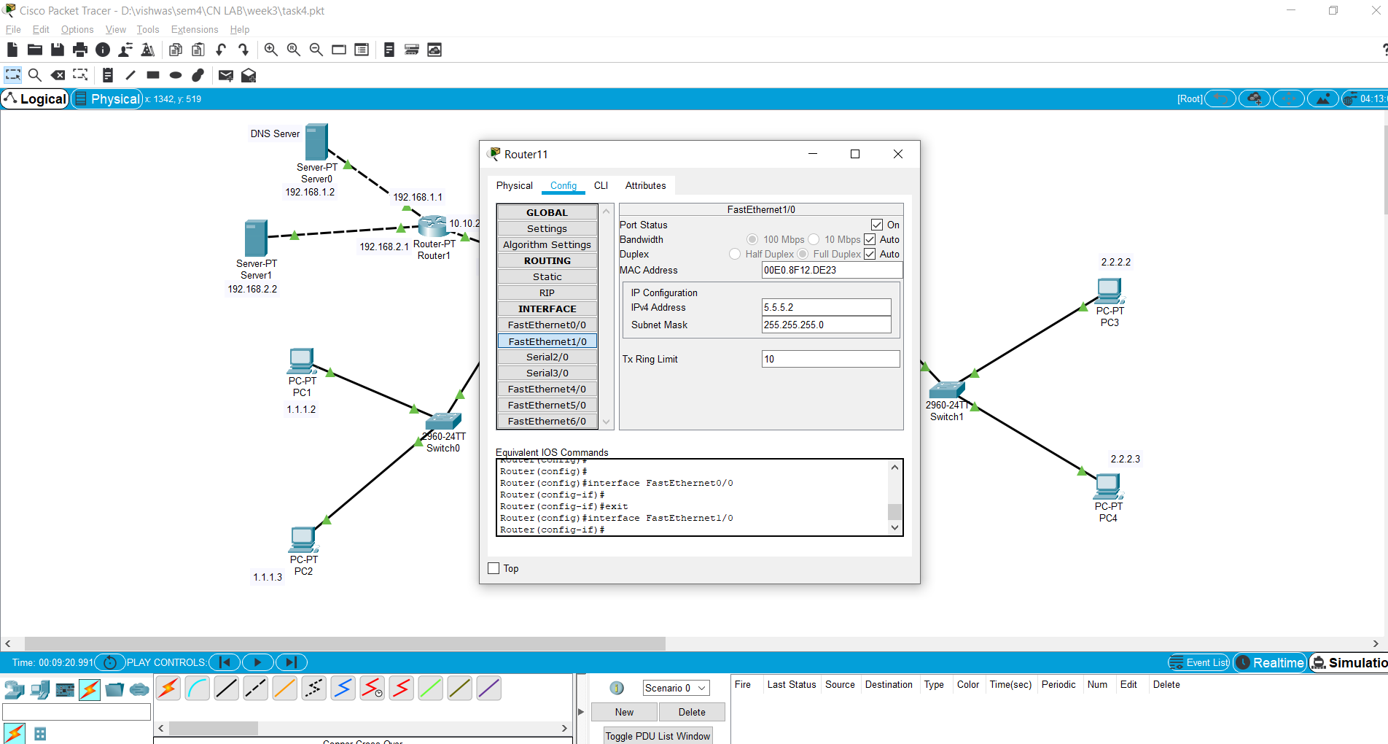

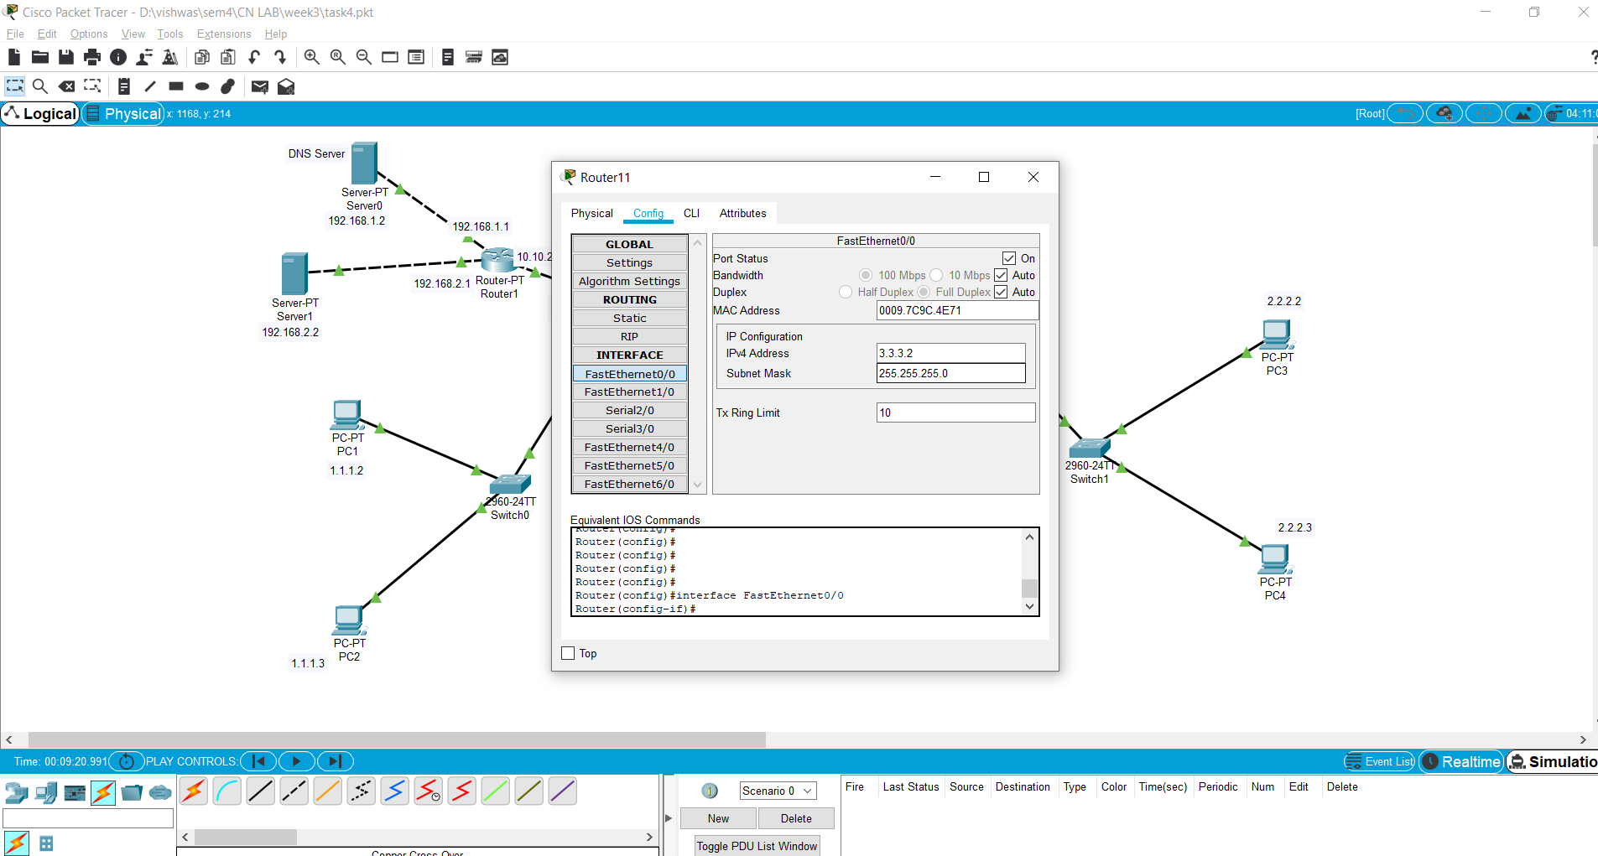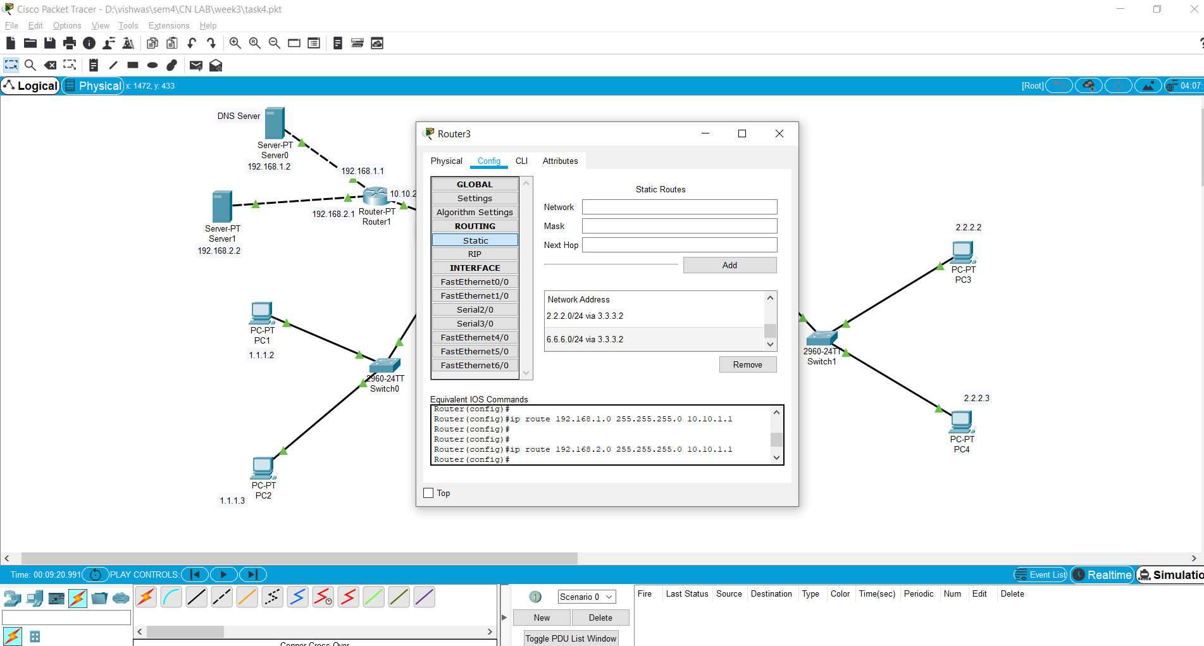

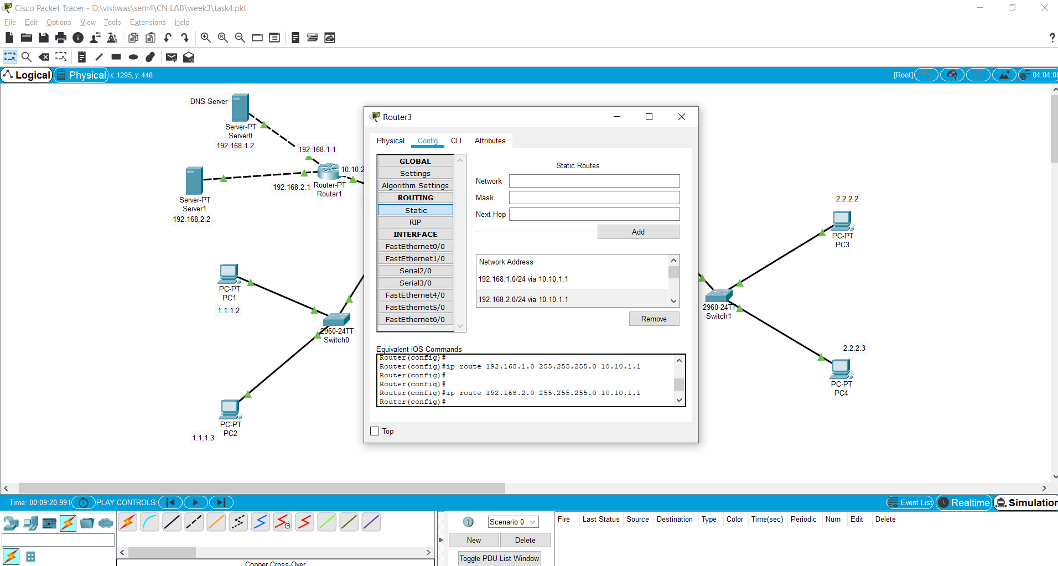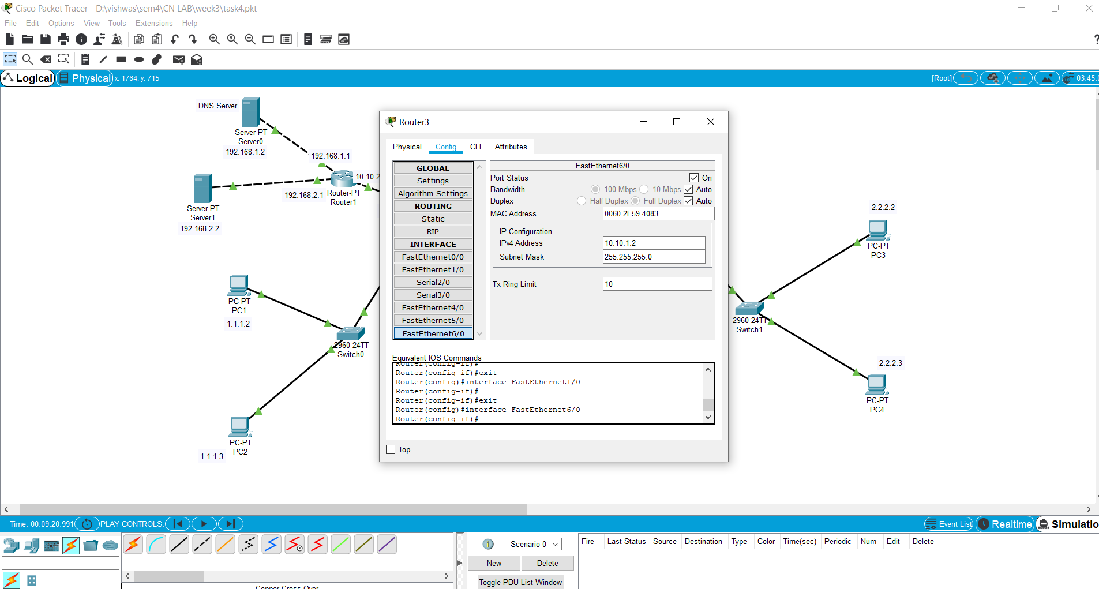

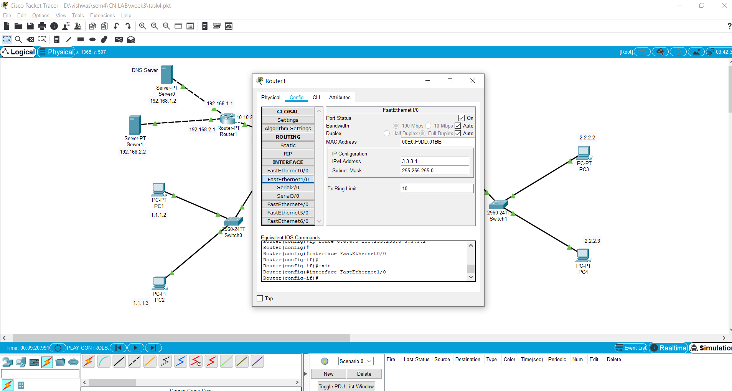

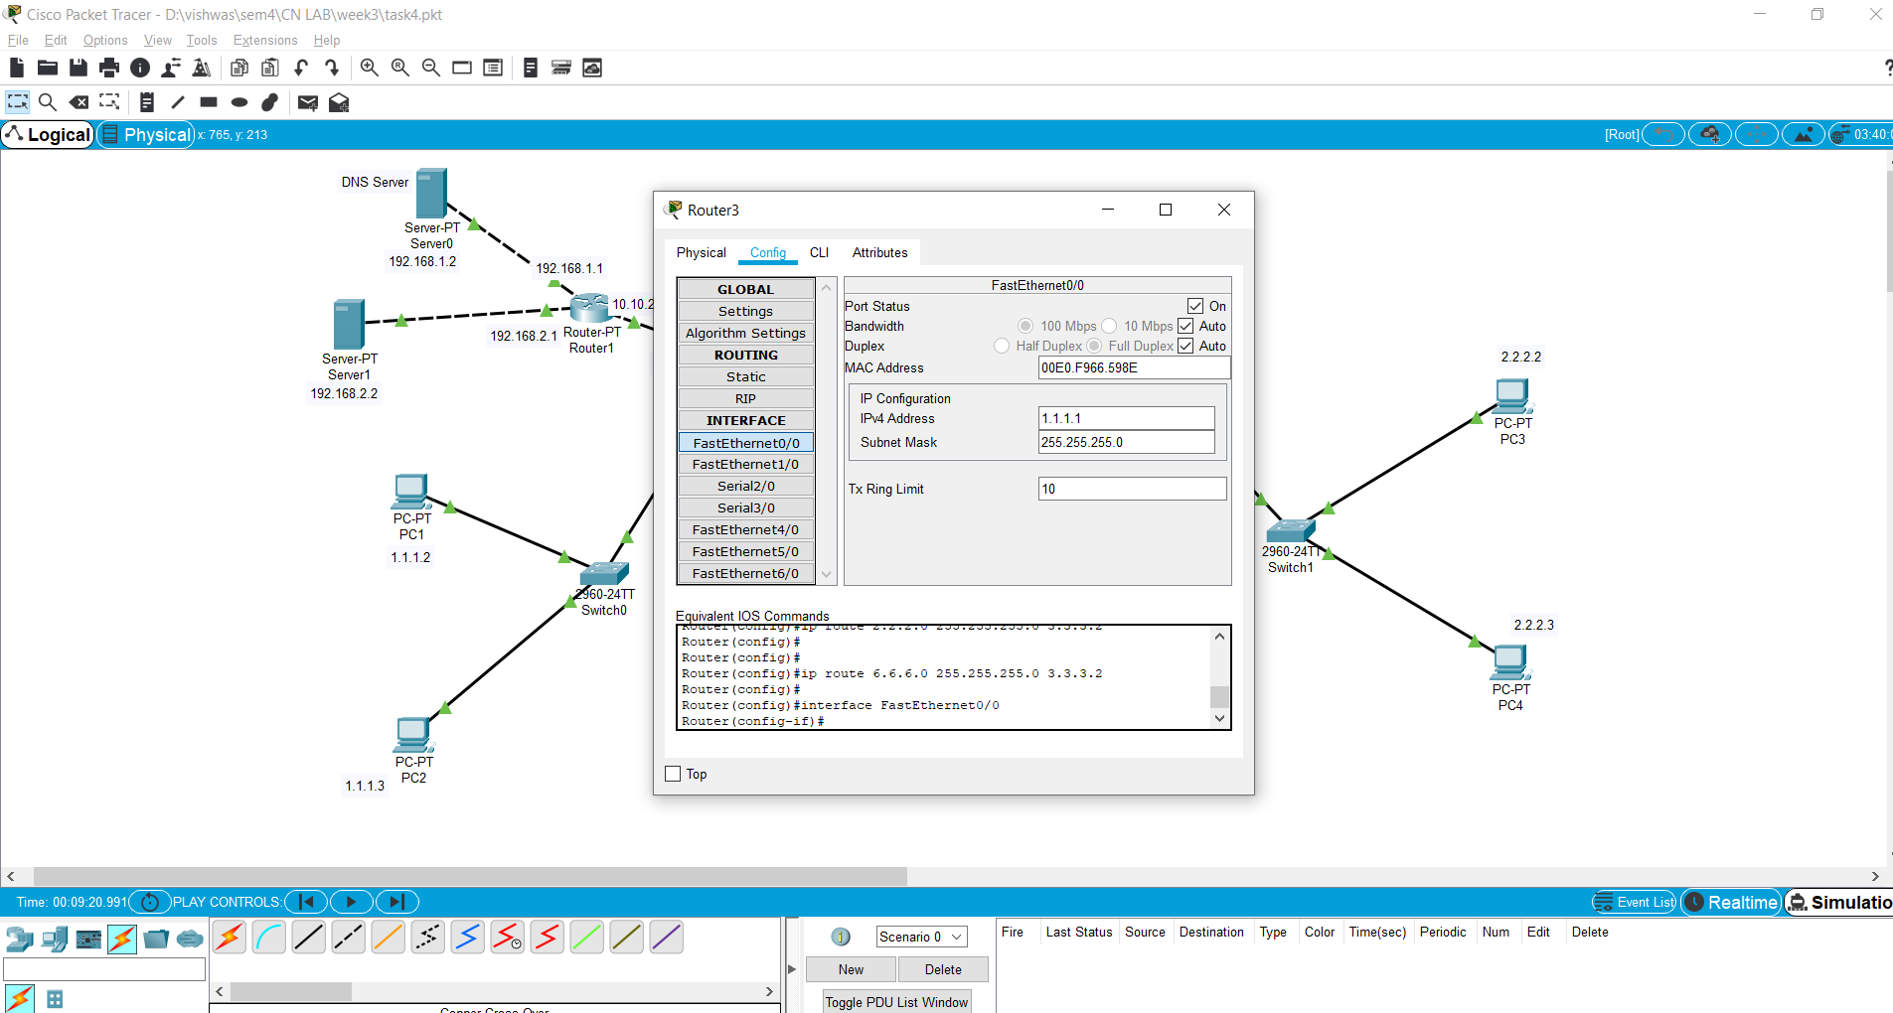

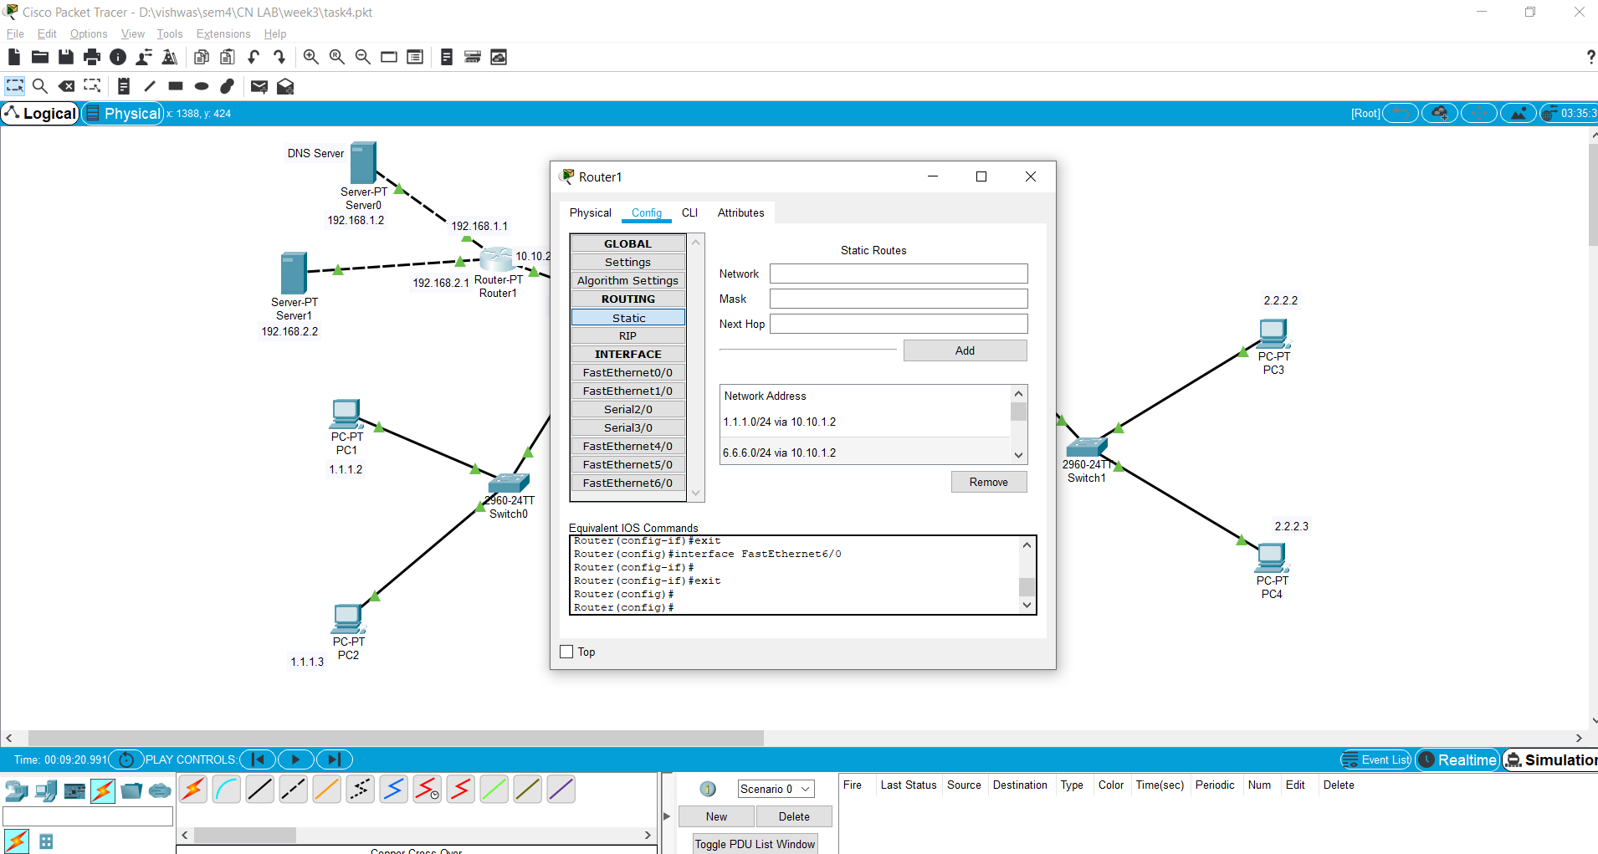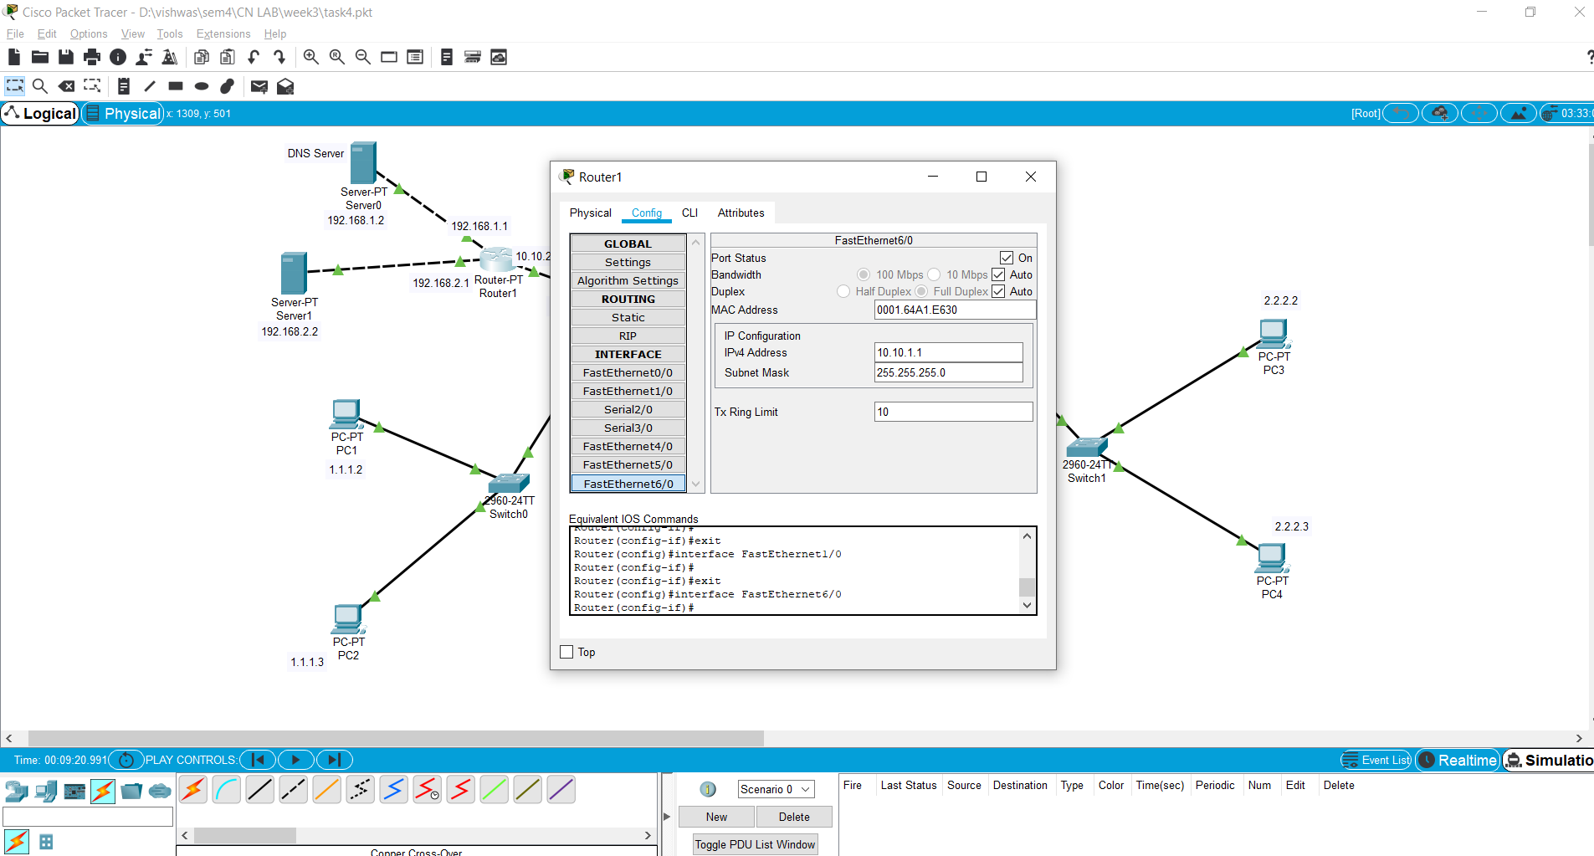

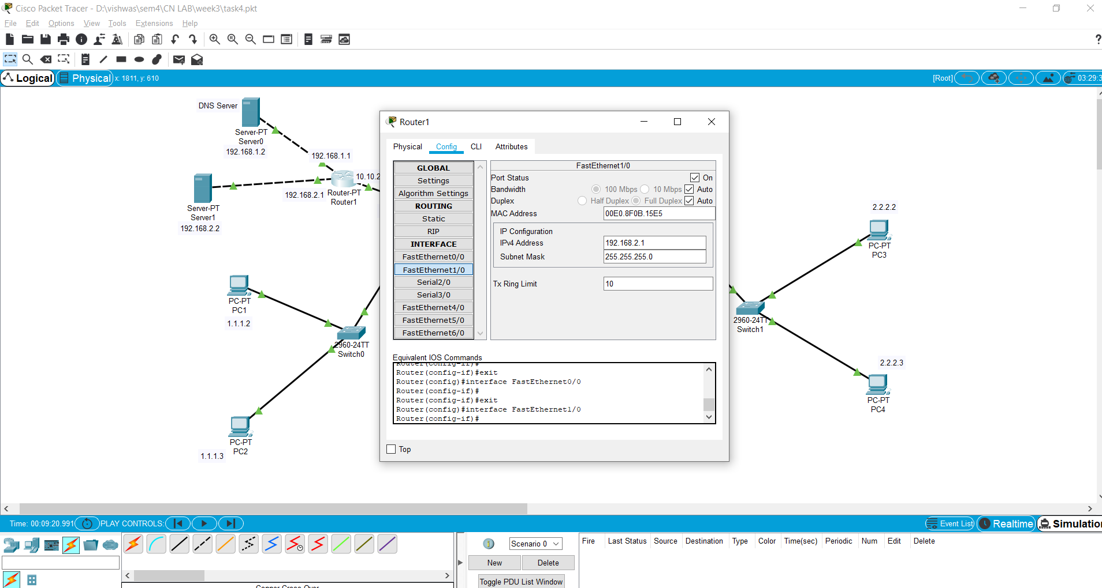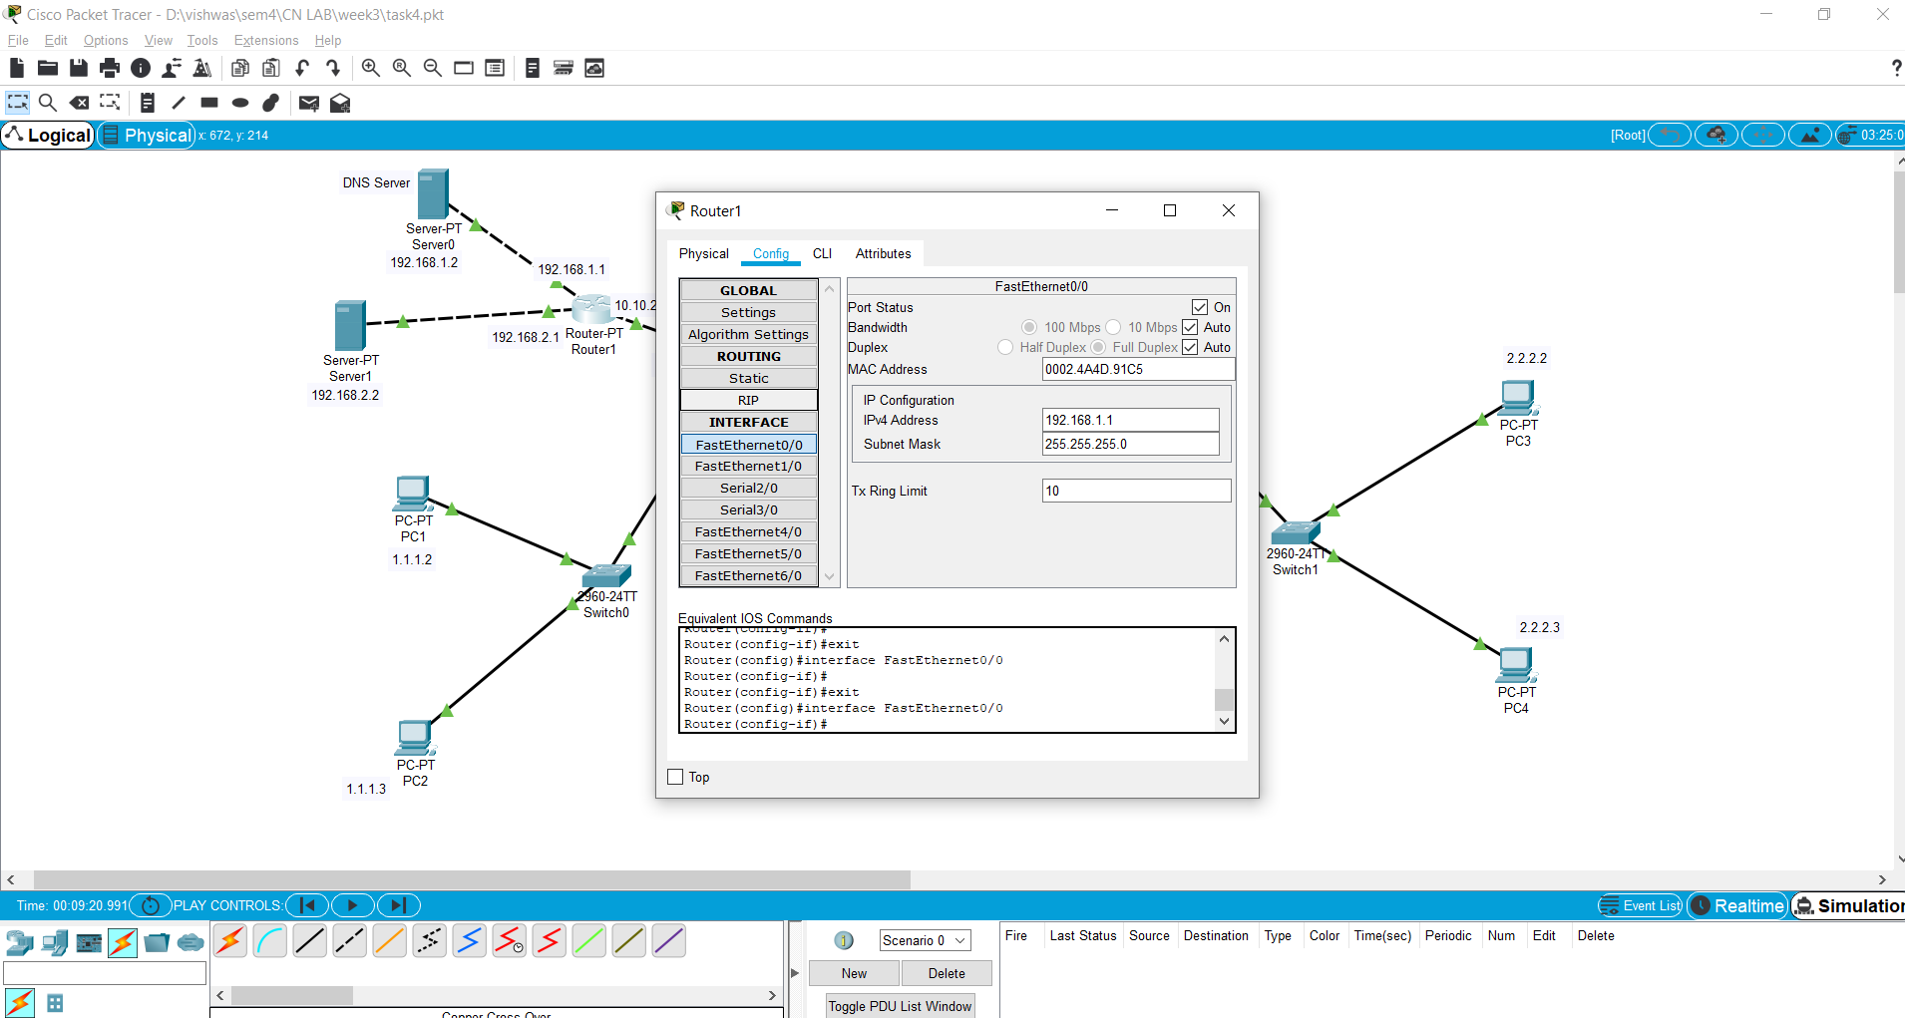

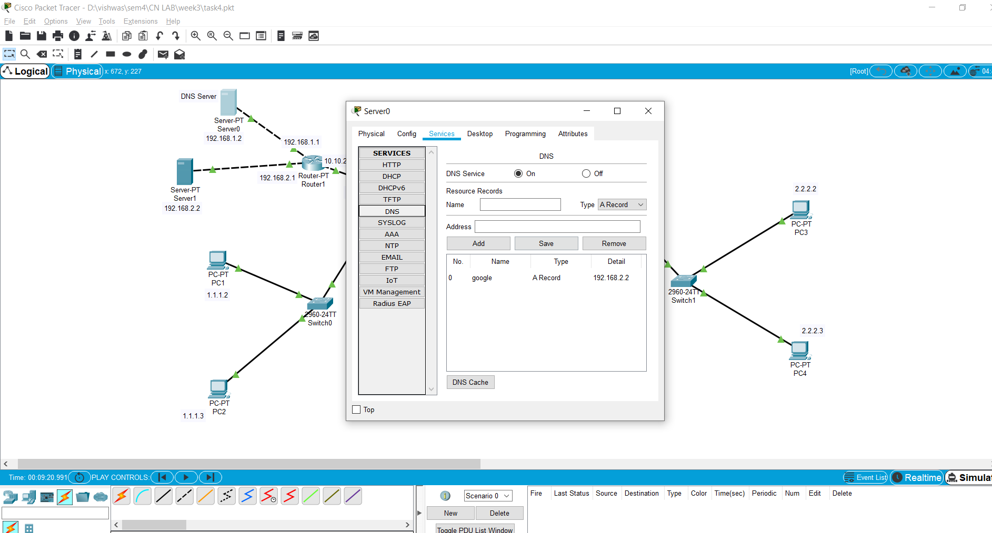

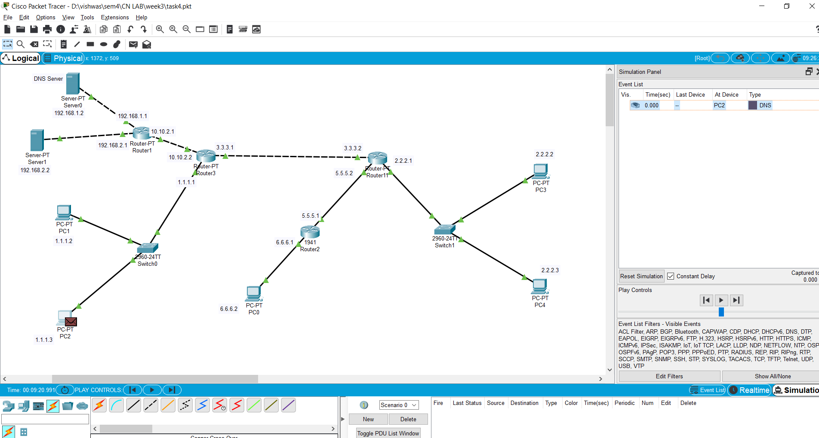

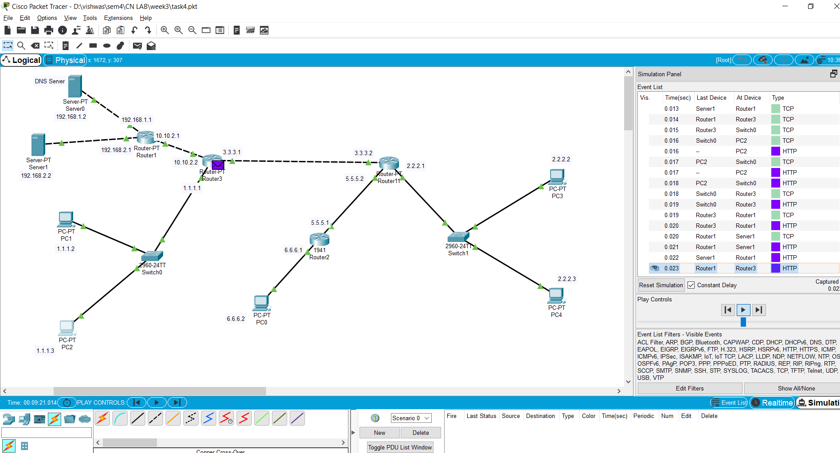

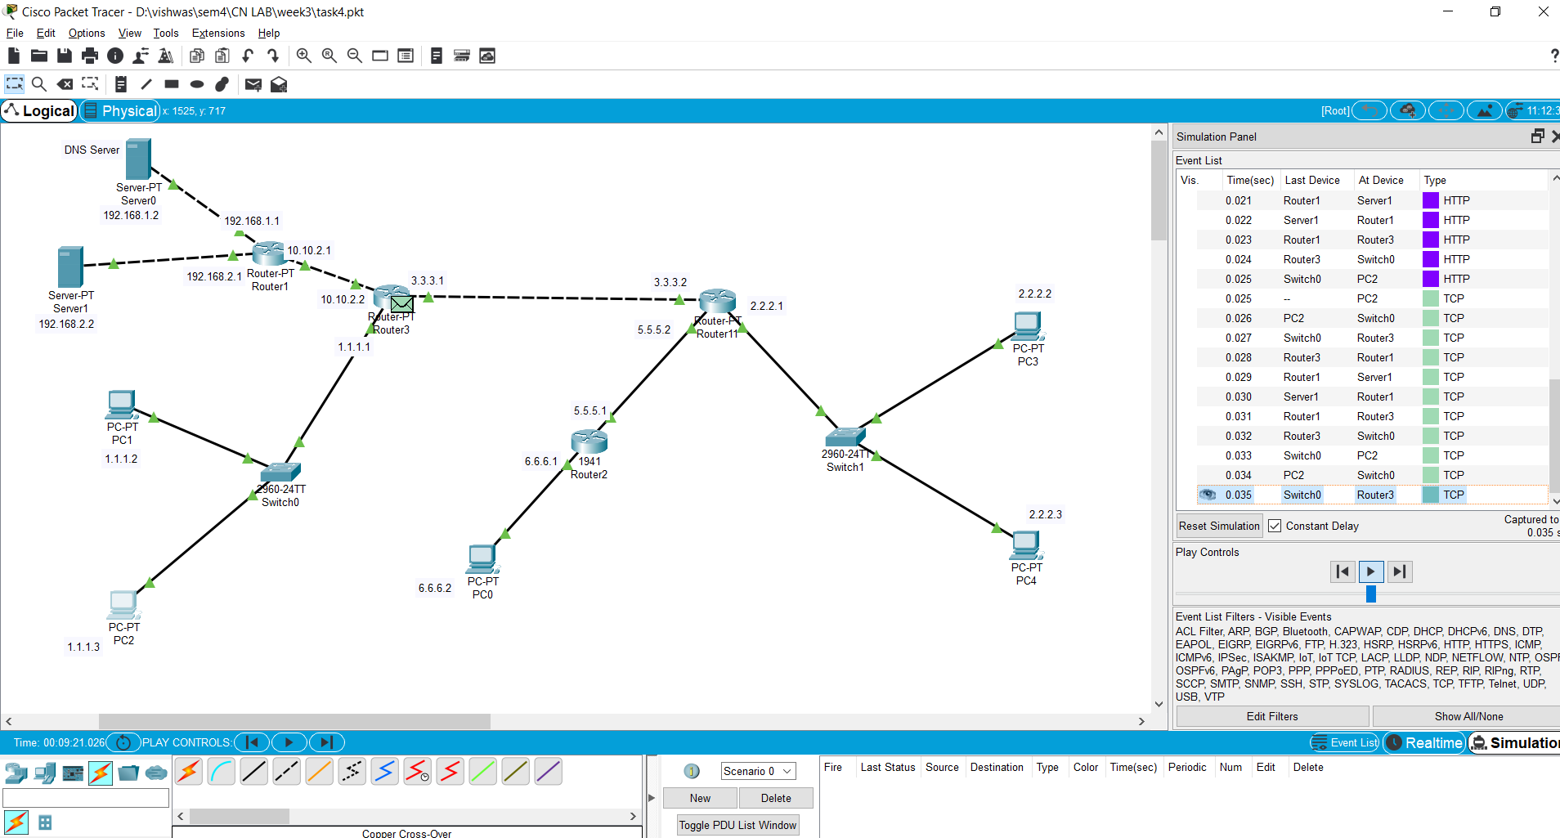

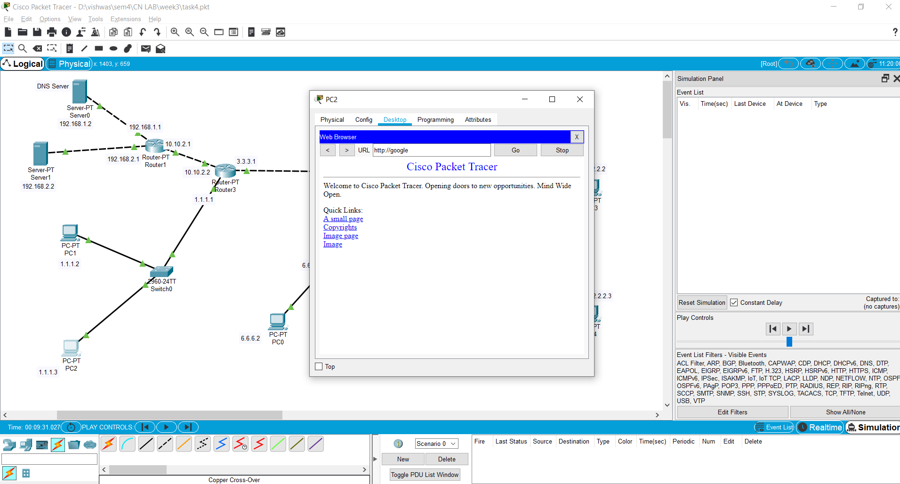

# OBSERVATIONS :

1. When the request for the domain "google.com" was made then because DNS serevr did not had the address in the cache the query took more

time to resolve the page (access the page back to the client from the web server) than in the followed request.

Time for 1st request : 0.328 seconds to capture (total time to fetch the page back.) Time for 2nd request : 0.019 seconds to capture (total time to fetch the page back.)

1. The reason for such a difference in time in the 2 requests being that DNS upon the first request of the web-server from the client

cached the DNS-name and the IP address in its local DNS cache and on the subsequent request again doesn't need to search for the

web-server again.

1. The ARP packets flowing were only seen in the first DNS request and not in the subsequent requset as because of the DNS cache.

ALl other packets i.e. TCP, HTTP and DNS were seen in both the web-server requests.

4.The colour coding was observed in the simulation mode

ARP : Green

HTTP : Purple DNS : Brown TCP : Green

5.The event list occuring is shown in the screenshots attached at the different places in the

topology.The number of packets got decreased by a fair amount as the ARP packets were not

in the picture.